2018 | May Newsletter

Bright Horizons at   
<Center Name> News

**From the Director**

Insert a note from the director here.

Important Dates

Insert important dates and times here…

Reasons to Celebrate

Insert notes on celebration here…

****Bright Horizons at <Center Name>****

Address, City, State, Zip

Phone | [Email](mailto:seneca@brighthorizons.com)

Days & Hours

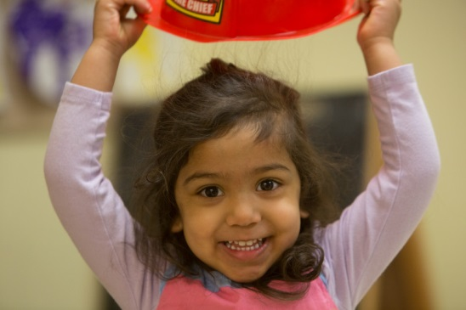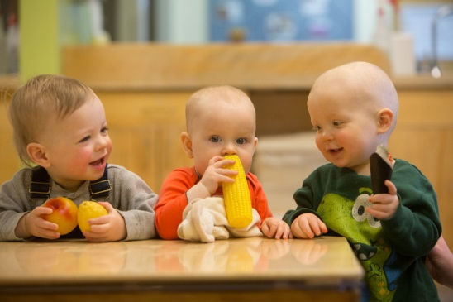

Infant

Insert body copy here…

Toddler

Insert body copy here…

Preschool

Insert body copy here…

Kindergarten Prep

Insert body copy here…

CLASSROOM HIGHLIGHTS

You’ve heard the statistics: one in five preschoolers is obese and the childhood obesity rate has tripled in the last 30 years. At Bright Horizons®, we’re passionate about children’s health and we believe this trend can be reversed. In 2011, Bright Horizons joined the Partnership for a Healthier America (PHA). As part of our PHA commitment, we’re updating physical education training materials for teachers to ensure that children get the physical activity they need every day. We’re also producing a host of resources for families. Building better health is as simple as becoming more physically active, one step at a time. Below are a few ideas for easy family fitness.

**Start a habit.**

Children aren’t particularly interested in why fitness is so important. They are interested, though, in fun family time. Establishing habits of physical activity in childhood paves the way for healthy adulthood. So, try to plan at least one physical activity on the weekend. Go for a walk, play at the park, or head to a pool. Think about building physical activity into your schedule at least three times during the week. This can be as simple as throwing a ball around before dinner or playing a quick game of hide and seek. It doesn’t have to be lengthy or complicated, but you do need to be intentional about it. Write it into your schedule so it becomes a habit.

**Get mobile.**

One of the simplest ways to get more exercise is by ditching the car. Walk, bike, or rollerblade to school, the store, the library – anywhere you can. Some areas are more “walk friendly” than others, of course, but try to walk as often as possible.

**Work it out.**

Family chores are another way to get moving. Raking leaves, weeding a garden, mopping the floor – all these activities get the body moving. Turn on some music and make chores a fun family time. Try to be consistent, as well. When children know that the family will spend an hour every Saturday working together, for example, they’re less likely to balk and more likely to see it as a predictable part of their family culture.





Family Fitness Fun

Ready for school News

Join us in celebrating our teachers & staff!

TEACHER & STAFF APPRECIATION MONTH

The greatest reward a teacher or staff member can receive is knowing that they have made a difference in the lives of children and families. Don’t miss the opportunity to celebrate and recognize all of the teachers and staff who make their classrooms a wonderful place for children and families.

Teacher Appreciation Day is May 8th but our teachers, support staff, and leadership team work hard all year long to make your child’s experience here the very best it can be. Help us celebrate them all month long!

Your thoughts make a difference – and mean a lot to all of us. Take a moment to share any stories, comments, and well wishes for those who touch your family’s life each day.

Visit our Teacher & Staff Appreciation Website to leave a special note of appreciation for your child’s teacher or exceptional staff member. The website will be open from May 1st through May 31st.

**appreciation.brighthorizons.com**





Check out all the places you can connect with us!

