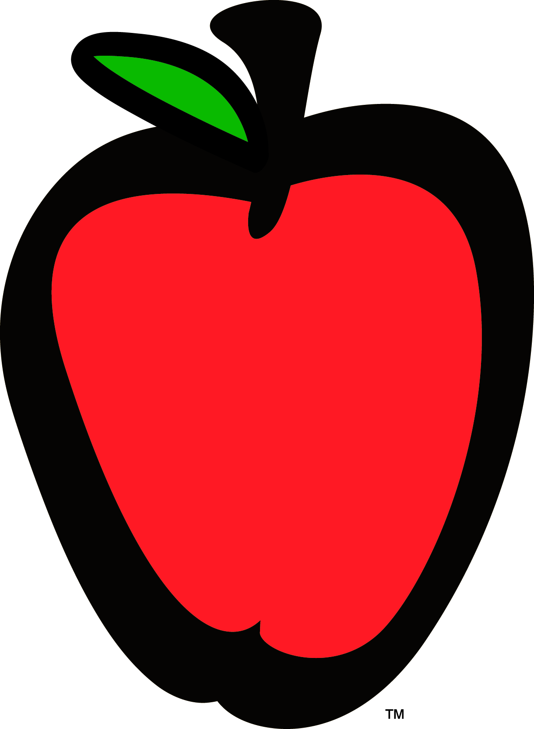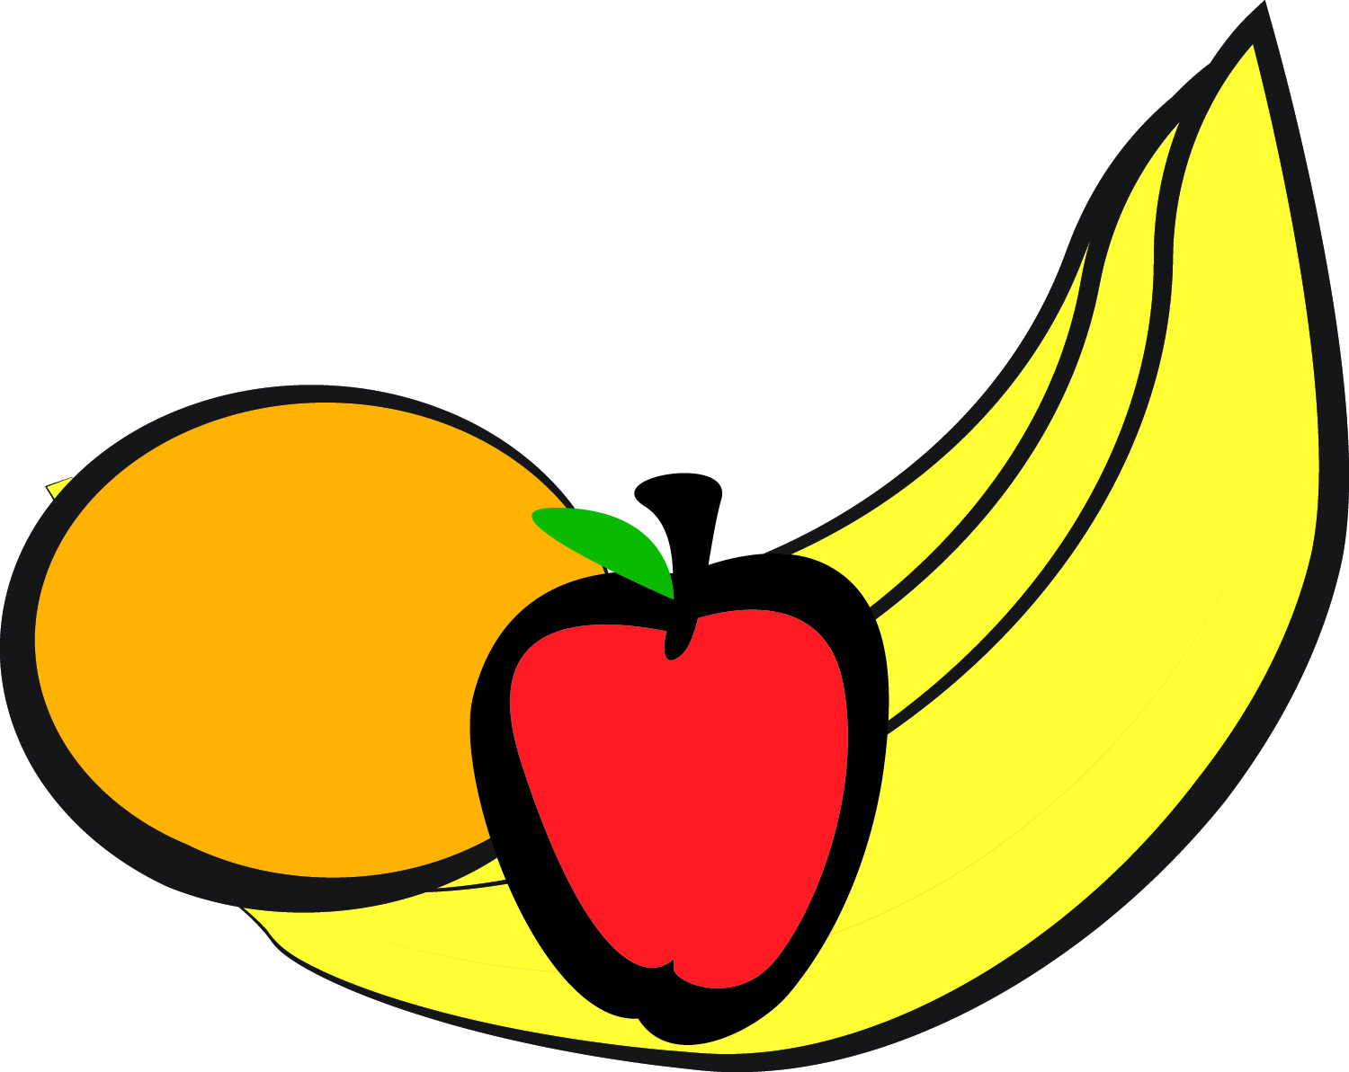

|  |  |  |  |  |
| --- | --- | --- | --- | --- |
| **MONDAY** | **TUESDAY** | **WEDNESDAY** | **THURSDAY** | **FRIDAY** |
| **2**  **AM Snack: Rice Krispies**  **Apricots**  **Lunch: Turkey Pepperoni Pizza**  **Chuck Wagon Corn**  **Pineapple**  **PM Snack: Graham Crackers w/ Peaches** | **3**  **AM Snack: Cream of Wheat**  **Pineapples**  **Lunch: Spaghetti w/ turkey meat sauce**  **Italian Blend**  **Pears**  **PM Snack: Fresh Orange Slices w/ String Cheese** | **4**  **C**  **L**  **O**  **S**  **E**  **D** | **5**  **AM Snack: Waffle Sticks**  **Mangos**  **Lunch: Grilled Chicken**  **Mashed Potatoes**  **Green Beans**  **Peaches**  **PM Snack: Sun Butter w/**  **Wheat Crackers** | **6**  **AM Snack: Blueberry Muffins**  **Fresh Melon**  **Lunch: Monte Crisco Sliders**  **Glazed Carrots**  **Mixed Fruit**  **PM Snack: Vanilla Yogurt w/ Strawberries** |
| **9**  **AM Snack: French Toast Casserole**  **Fruit Medley**  **Lunch: Shepherd’s Pie w/Ground Turkey**  **Mixed Vegetables**  **Tropical Fruit**  **PM Snack: Vanilla Wafers**  **Bananas** | **10**  **AM Snack: Cheerios**  **Peaches**  **Lunch: BBQ Sliders**  **Green Beans**  **Pasta Salad**  **Fresh Melon**  **PM Snack: Pretzel Bites**  **Apricots** | **11**  **AM Snack: Oatmeal**  **Peaches**  **Lunch: Turkey Meatloaf w/ Gravy ;Basmati Rice**  **Capri Vegetables**  **Tropical Fruit**  **PM Snack: Mixed Berry Parfait** | **12**  **AM Snack: Biscuits w/ Turkey Sausage**  **Bananas**  **Lunch: Zesty Orange Chicken**  **Oven Fried Rice**  **Steamed Capri Vegetables**  **Pineapples**  **PM Snack: Graham Crackers**  **Orange Slices** | **13**  **AM Snack: Cheese Grits**  **Turkey Sausage**  **Pineapples**  **Lunch: Corn Taco Shell w/ Ground Turkey**  **Chuck Wagon Corn**  **Baked Apples**  **PM Snack: Turkey w/ Cheese**  **Wheat Thins** |
| **16**  **AM Snack: English Muffin**  **Fresh Melon**  **Lunch: Chicken Enchilada Casserole**  **Normandy Blend**  **Pineapple**  **PM Snack: Cheese Crackers**  **Tropical Fruit** | **17**  **AM Snack: Blueberry Muffins**  **Pineapple**  **Lunch: Cheese Tortellini w/ Marinara**  **Bermuda Vegetables**  **Fresh Melon**  **PM Snack: Graham Crackers w/ Pears** | **18**  **AM Snack: Oatmeal**  **Fresh Melon**  **Lunch: Baked Chicken**  **Macaroni Cheese**  **Collard Greens**  **Corn Muffins**  **Pears**  **PM Snack: Sun Butter w/**  **Carrot Sticks** | **19**  **AM Snack: Bagels w/ Cream Cheese Strawberries**  **Lunch: Mango Chicken**  **Roasted Brussels Sprouts**  **Jasmine Rice**  **Corn Muffins**  **Mixed Fruit**  **PM Snack: Yogurt**  **Apricots** | **20**  **AM Snack: Waffle Sticks**  **Strawberries**  **Lunch: Pasta Alfredo w/ Chicken**  **Normandy Blend**  **Breadsticks**  **Strawberries**  **PM Snack: Fresh Melon w/ Vanilla Yogurt** |
| **23**  **AM Snack: Cheese Grits**  **Turkey Sausage**  **Bananas**  **Lunch: Corkscrew Pasta w/ Alfredo**  **Bermuda Vegetables**  **Pineapples**  **PM Snack: Graham Crackers w/ Pears** | **24**  **AM Snack: Rice Krispies**  **Peaches**  **Lunch: Cheese & Turkey Sandwich**  **Sweet Carrots**  **Sliced Apples**  **PM Snack: Vanilla Yogurt w/ Strawberries** | **25**  **AM Snack: Cream of Wheat**  **Pineapples**  **Lunch: BBQ Chicken Pizza**  **Sweet Corn**  **Mixed Fruit**  **PM Snack: Fresh Apple Slices w/ String Cheese** | **26**  **AM Snack: Bagel w/ Cream Cheese**  **Fresh Melon**  **Lunch: Broccoli w/ Chicken Casserole**  **Basmati Rice**  **Mixed Fruit**  **PM Snack: Spinach Artichoke Dip w/ Pita Chips** | 27  **AM Snack: Oatmeal**  **Strawberries**  **Lunch: Chicken Quesadillas**  **Sweet Corn**  **Pears**  **PM Snack: Cheese Crackers w/ Tropical Fruit** |
| **30**  **AM Snack: English Muffin**  **Fresh Melon**  **Lunch: Pasta w/ Marinara Sauce Turkey Meatballs**  **Normandy Blend**  **Pineapple**  **PM Snack: Sun Butter w/**  **Wheat Crackers** | **31**  **AM Snack: Cream of Wheat**  **Pineapples**  **Lunch: Chicken Tenders**  **Green Beans**  **Mashed Potatoes**  **Mixed Fruit**  **PM Snack: Fresh Apple Slices w/ String Cheese** |  |  |  |

**LAA serves whole milk to children less than two years of age and 1% milk to children over two years of age.**

**Milk is served at AM snack and lunch. Water is served at PM snack**

Little Apron Academy

July 2018