*Super* Hero

Costumes Welcomed

**Come have a**

***SUPER* time!**

Summer Bash

Tuesday, June 13th

4-6 pm

Festivities will include…

* Super Hero Activities
* A Face Painter
* Photo Booth
* A Delicious Fruit Bar

Important Dates

June 12th ~ Summer Bash 4-6 pm

June 15th ~ Digging with Dad 4-6 pm

June 18th ~ Bubble Juggler 10 am

June 29th ~ Kohl Children’s Museum 9:45 am (PS & KP)

**Looking Ahead**

July 4th ~ Center Closed



**The Art of Being a Father**

* **Spend Time with Your Child.** How a father spends his time reveals to his child what is important to him. Children grow up quickly and the time to bond with them is now.
* **Be a Role Model.** Whether they realize it or not, fathers are role models to their kids. A girl who spends time with a loving father grows up knowing she deserves to be treated with respect by boys and she learns what to look for in a partner. Fathers teach boys and girls what is important in life by demonstrating honesty, humility and responsibility.
* **Eat Together as a Family.** Sharing a meal together is an important part of a healthy, family life. It gives kids the chance to talk about what they are doing and want to do. It is also a good time for fathers to listen and be involved. It provides a structure for families to be together each day.
* **Read To Your Child.** In a world dominated by television and internet, it is important that fathers make the effort to read to their children. Begin reading when they are very young and as they get older, encourage them to read on their own. Instilling a love of reading is one of the best ways to ensure children will have a lifetime of literacy and personal and career growth.

Few events change a man's life as much as becoming a father. Being entrusted with the responsibility and care of another person is a monumental task but none is more rewarding than to see your child grow gradually into adulthood, with your affection returned in good measure and your child's self worth confirmed. A father's influence, feelings, and hope for and about his children run deep. Unquestionably, fathers care!

2018 | June Newsletter

Bright Horizons at   
Rosemont News

****Bright Horizons at Rosemont****

6107 N. River Road Rosemont, Il 60018

847-384-5650 | [rosemont@brighthorizons.com](mailto:rosemont@brighthorizons.com)

Monday-Friday | 6:30 am-6:30 pm

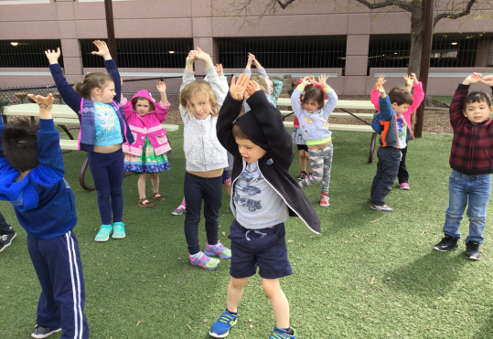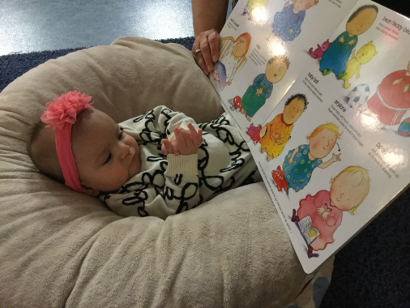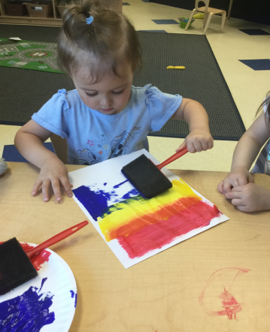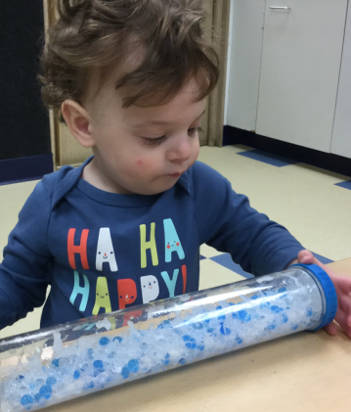

Infant

*Language Works* curriculum for infants guides the teachers-child experiences through positive support for communication. It provides a framework for the use of language, expression, tone of voice, body language, and classroom materials, thereby ensuring that teachers model communication skills through everyday experiences with the baby. Whether it’s by singing a soothing lullaby, naming objects during a playful activity, or participating in a reciprocal conversation (even when the infant only responds in babbles), infant teachers are continually encouraging blooming language skills.

Toddler

*Science Rocks* provides a framework for teachers to weave scientific learning into all aspect of toddler’s day. Through intentional experiences, meaningful conversations, and enriched environment-asking children “what if” questions, growing herbs in a paper cup garden, recording what objects float or sink in a water table-teachers help children become skilled observers, inquisitive investigators, and life-long researchers.

Young Preschool

*ArtSmart* ensures that children are engaged in comprehensive, authentic, and diverse creative experiences in all areas including visual arts, music, dance/creative movement, and drama, nurturing a child’s own artistic abilities and helping her appreciate art in the broader world. By insuring art into preschool environments and offering preschoolers a variety of creative experiences each day, teachers enhance cognitive development, support self-expression, and nurture the budding artist in each child.

Preschool

*Our World*, a part of *The World at Their Fingertips* curriculum, presents unique experience to help children understand the diverse and global world they inhabit, enhancing their sense of responsibility and compassion for people here and aboard. Teachers cultivate the development of these important competencies through modeling and activities, and by creating a preschool environment that is respectful and diverse.

CLASSROOM HIGHLIGHTS

It’s never too early to start “growing readers”! Research has shown that children who have a close adult who reads to and with them -- especially in the very early years -- learn language and literacy skills, develop an appreciation of books, and experience stronger family relationships.

Reading with your child can be one of the most rewarding and memorable ways to spend time together. In addition to having lasting effects on cognitive, language, and literacy development, sharing books inspires your child’s curiosity and creativity. Cuddling up with a book is an intimate activity that builds strong, loving, lifelong bonds.

**A few tips for reading with your child:**

* Designate a regular time and place to curl up together with a book. Invite your child to select books but also introduce new stories.
* Before you begin a new book, talk about the title, the cover, the author, and the illustrator. Ask thought-provoking questions about the book. "What do you think this story is about?"
* Understand that young children love to hear the same stories over and over again. Repetition provides a level of comfort and enables children to become the experts on the storyline. Also, it allows them to get familiar with the words, and eventually “read” the book to you.
* Make reading interactive; ask questions such as, “What do you think happens next in the story?” Or "How would you handle this situation?” It’s interesting to hear your child’s impression of the story.
* Expand your child’s horizons. When your child develops a new interest, go to the library and find books on that subject.
* Have fun and be playful! When you read aloud, try to make your voice exciting and dramatic for the different parts of the story.

There is so much multicultural, informative, historical, traditional, silly, experiential, and even futuristic literature for young children these days. Refer to “Bright Horizons Growing Readers” to access family resources, books suggestions, at-home reading activities, and tips on reading aloud.

[**www.brighthorizons.com/childrenbooks**](http://www.brighthorizons.com/childrenbooks)





Homegrown Readers

Ready for school News

Learning at Home: Summer Activity

BRIGHT HORIZONS NEWS

Our Learning at Home ideas offer parents fun ways to extend their child's learning opportunities beyond the classroom to take advantage of teachable moments that naturally emerge from everyday life situations.

**Beach in a Bottle** – *Suitable for Kindergarten, Multi-Age, Preschool, School Age, Toddler, Twos*

**You will need:**

A trip to the beach, lake or creek, and supplies: plastic bottle, super glue, permanent marker, and a label

**Directions:**

Have your child fill the bottle with sand and water from the beach, along with their favorite sea shells or small pieces of driftwood. Seal the top using super glue (keep the glue out of your child’s reach and let the bottle dry before using it with them). Label with the date and location of your outing.

[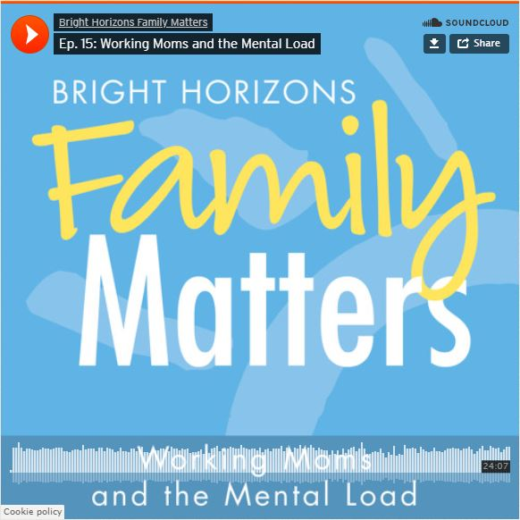](https://www.brighthorizons.com/family-resources/podcasts/working-moms-mental-load)

**New Parenting Podcast Episode!**

Peaceful Parenting on Busy Workdays

We’ve all been there… the get-out-the-door chaos, the after-work frenzy, those toddler-parent moments when things just seem to go kaboom! Is there a better way? Parenting expert and psychologist Jennifer Gillette says unequivocally… yes.

On this episode of the *Work-Life Equation*, Gillette has the tips, tricks, and strategies to tame the tantrums and put what she calls Peaceful Parenting back into your busy day.

[**Ep. 17: Peaceful Parenting on Busy Workdays**](https://soundcloud.com/user-48566546/ep-17-peaceful-parenting-on-busy-workdays)[www.brighthorizons.com/peacefulparenting](http://www.brighthorizons.com/peacefulparenting)



Check out all the places you can connect with us!

