



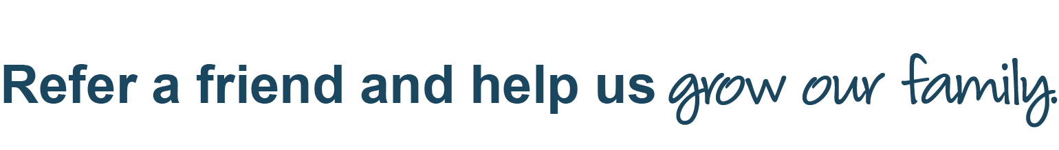

When you make a referral, you’ll help us continue to spread excitement about learning and help children build a solid foundation for future success. Simply complete this form and email it to your center director. We’ll reach out to your friend to schedule a tour.

­­­

|  |  |  |  |  |
| --- | --- | --- | --- | --- |
| **Your Name:** |  | | | |
| **Your Email:** |  | | | |
| **Friend’s First Name:** | | |  | |
| **Friend’s Last Name:** | | |  | |
| **Friend’s Email:** | |  | | |
| **Name of Child:** | |  | | |
| **Age of Child *(if known)*:** | | | |  |

**Bright Horizons at <Your Center Name>**

Street Address, City, State Zip | 000.000.0000

email@brighthorizons.com | brighthorizons.com/email

*\*This offer is only available at participating Bright Horizons centers. Credits are non-transferrable and are limited to one credit per child or family. All credits are applied after the referred family has been enrolled for 30 days. This offer is available from 8/1/2019 to 8/31/2019. All referrals and enrollments must be made before 8/31/2019.*

*Offer is valid only for children not previously enrolled at a Bright Horizons center. Offer cannot be combined with any other offers.*

© 2020 Bright Horizons Family Solutions LLC