Bright Horizons at Columbus Circle
910 9th Ave. New York, NY 10019
212.399.3919 | columbuscircle@brighthorizons.com
Monday – Friday 7:00 am – 6:30 pm

Bright Horizons at
Columbus Circle News
From the Director
Happy November!
We want to personally thank you all for understanding our water-shut crisis and making the day as seamless as possible.
On November 15th, please join us for “International Night”! Each classroom will be a country or culture to represent. During the evening event, families will travel to each classroom with a "passport." Once you have visited a “country” each child will receive a stamp. We look forward to seeing you there!
Great news! We will be extending or Scholastic Book Fair for another week! Our book fair will be Infant 1 classroom (the first classroom on your left when you enter the center). Please note Columbus Circle will receive a percentage of all sales that will be used specifically to purchase books for all of our classrooms!
Outside of each classroom you will find a sign-up sheet for the week of Thanksgiving. Our intent is to allow as many staff as possible to spend extra time with their families, so we want to get an accurate count of how many students will be present during these days so we can staff accordingly. Please take a moment to fill it out!

Thanks
Karyn Alston
Important Dates
Tuesday, November 6th – ELECTION DAY

Wednesday, November 7th – Family Partnership Call at 1:00 pm

Sunday, November 11th – Veteran’s Day

Thursday, November 15th – International Fair from 5:00-6:30

Thursday, November 22nd and Friday, November 23rd - CLOSED

Happy Birthday!!

Kyle M. – November 5th
Alexandra B. – November 6th
Ms. Katherine – November 10th
Sana N. – November 17th
Alessandro R. – November 22nd
Amara W. – November 26th
Ms. Fanny – November 26th

2018 | November Newsletter

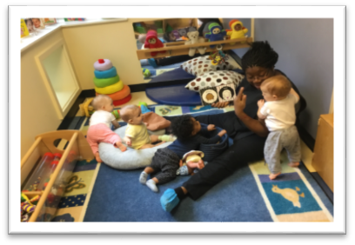
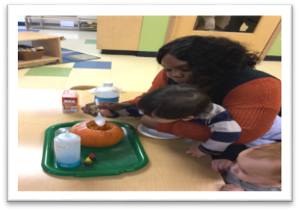
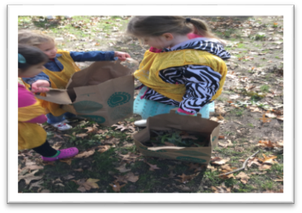
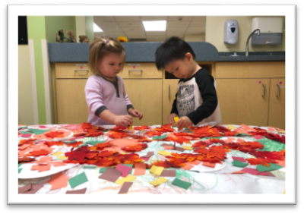
Program HIGHLIGHTS
Language Works
Reading aloud to children is the single best predictor of a child’s later success as an independent reader. Children who are read to often develop an interest in books, perfect their listening skills, develop a diverse vocabulary, and develop related skills like rhyming and decoding of words. The reading experience is very different with infants from older children. Turning pages, or holding or chewing the book are part of the experience. Whether you look at one page or many pages together, infants are introduced to the book and the stage is set for a lifelong love of reading.
Science Rocks
Science Rocks includes opportunities for children to hypothesize, gather data, experiment, form conclusions, and make representations of the results. Our Toddlers have been enjoying Autumn by manipulating objects from the natural world and explore different textures and smells. They also combined different elements to see how it will change the property of the object!

Art Smart
During a process art experience, teachers inspire children with rich, familiar - as well as changing - environments and introduce new and familiar materials and concepts, but allow children to take it from there. When engaged in the process of exploring materials, children develop many skills and abilities. Among other things, they learn to take initiative, develop cognitive and physical skills while increasing confidence, competence, independence, and a personal sense of aesthetics. Process oriented art enhances children’s self-esteem because they are successful regardless of what the end product looks like.

Outdoor Exploration
Outside is more than a place to run around and “burn energy”. By making the outdoor environment an extension of the homebase, we can fully support the children's cognitive, social, and emotional development. It’s up to us to offer a full range of activities and take advantage of two important aspects of a child’s life, “nature, in all its transcendent, powerful glory” and ”open spaces and physically challenging spaces, places to literally take off, scale, and explore.”

EDUCATION News
Learning a New Language: A Family Activity that Lasts a Lifetime

Our country is a beautiful melting pot of people from all over the world. As we know, there are many different languages spoken on earth. Being able to talk to each other is an essential path to build bridges. Also, having the ability to communicate with people who speak a different language encourages cross-cultural understandings, which opens the door to new friendships. Think about how welcome someone feels when your family smiles and says hello in their native language. Have you ever considered learning a foreign language along with your child?
Research shows that exposing young children to different languages taps into their innate ability to distinguish sounds, which enhances their growing cognitive skills. Because young children generally learn a new language more quickly than adults, your child might take the lead. There are many language learning opportunities online, from interactive exercises that teach language to watching YouTube videos. Some are even free, while others require purchasing a program. Two recommended websites:
Duolingo
www.duolingo.com offers interactive lessons in Spanish, French, Italian, German and Portuguese.
Mamma Lisa’s World of Children and International Culture
www.mamalisa.com offers poems, songs, rhymes and traditions from around the world, in over 57 languages.

As you begin learning a language together, you might delve into the culture of the countries where the language is spoken, pick up children’s books in that language or prepare a traditional recipe from that country.
Everything we do as a family builds a stronger, more caring, cohesive unit. Practicing a new language broadens our view of the world. It’s fun and can be done anywhere: while taking walks, commuting, playing a game, listening to music, dancing, dining, reading bilingual books, and watching a movie.



BRIGHT HORIZONS NEWS
Thanksgiving Prep - Tips for Involving Kids

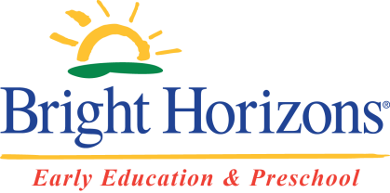



1) Make the cranberry sauce with the kids the weekend before Thanksgiving. It will keep and it allows you to include the children in the cooking process.
2) Have the kids make place cards together. Give them index cards, markers, crayons and stickers. Older children can write the names, inventive spelling and all, while younger children can decorate with stickers.
3) Try to find the easiest Thanksgiving worthy appetizers you can that the children can help prep by counting crackers, opening jars, and arranging plates.
4) Ask them to be taste testers and enjoy your Thanksgiving meal!

Check out all the places you can connect with us!

Podcasts for Parents on the Go
Did you know that Bright Horizons has a podcast? Navigate your parenting journey with our podcast series created with working parents in mind.
Tune into our podcast, The Work-Life Equation, to hear about parenting, caregiving, and balancing work with everyday life. Whether you’re a working or stay-at-home parent, you’re likely always on-the-go. But throughout the daily hustle and bustle, you have questions, concerns, and simply need support.
Our parenting and education experts are here to help you navigate the parenting journey with an “on-the go” podcast you can listen to when convenient for you.
Browse our episode selection at brighthorizons.com/family-resources/podcasts

