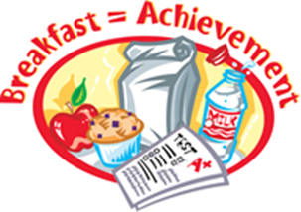
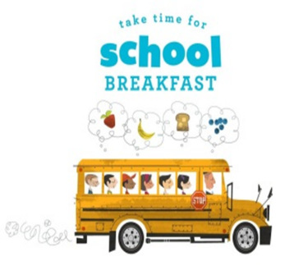
November 2022 LUNCH

MONDAY | TUESDAY | WEDNESDAY | THURSDAY | FRIDAY
 | 1  Turkey Cheese Slider  Pickled Veggie Crudites  Fruit | 2  Ravioli w Meat Sauce Roll  Vidalia Onion Squash Bake  Fruit | 3  Roast Turkey Gravy Roll  Mashed Potatoes  Roll  Fruit | 4  Cheese Pizza  Savory Mixed Veggies  Fruit
7  Mini Turkey Corn Dog  Honey Buttered Baby Carrots  Fruit | 8  Chicken Queso Rice Bowl  SW Pico Corn Bean Salad  Fruit | 9  Chicken Alfredo  Roll Broccoli Carrots  Fruit | 10  Chicken Nuggets Roll  Mac n Cheese  Fruit | 11  Veteran’s Holiday  School Closed
14  Beef CheeseTaquitos  Cilantro Chopped Veggie Slaw  Fruit | 15  Ravioli Meat Sauce w/Roll  Savory Veg Medley  Fruit | 16  Turkey Cheese Croissanwich  Pickled Veggie Crudites  Fruit | 17  Sloppy Joe Bun  Potato Salad  Fruit | 18  Cheese Pizza  Green Bean Casserole  Fruit
21  Mini Turkey Corn Dog  Honey Buttered Baby Carrots  Fruit | 22  Roast Turkey Gravy Roll  Mashed Potatoes  Pumpkin Cookie  Fruit | 23  Cheese Pizza  Yogurt  Jello Salad  Fruit | 24  THANKSGIVING HOLIDAY | 25  THANK YOU FOR OUR TEACHERS
28  Chicken Nuggets Roll  Mac n Cheese  Fruit | 29  Ravioli MS w/Roll  Savory Veg Medley  Fruit | 30  Turkey Cheese Sliders  Pickled Veggie Crudites  Fruit

