January 2020
 | MONDAY | TUESDAY | WEDNESDAY | THURSDAY | FRIDAY
January 1-3 |  |  | 1  Happy New Year!  Small Wonders Closed | 2  Mini Twin Cheeseburgers  Broccoli  Mandarin Oranges | 3  Toasted Cheese  Sweet Potato Fries  Mixed Fruit
January 6-10 | 6  Cheese Quesadilla  Salsa  Tropical Fruit Salad | 7  Chicken Nuggets with Sweet & Sour Sauce  Potato Emojis  Diced Peaches | 8  Hamburger with Whole Grain Bun  Yellow Corn  Applesauce | 9  Italian Dipper Pierogis  Marinara Cup  BBQ Baked Beans  Fresh Oranges | 10  Homestyle Chicken Bowl  Green Beans  Mixed Fruit
January 13-17 | 13  Cheese Pizza  Broccoli & Cheese  Tropical Fruit Salad | 14  Salisbury Steak with Mashed Potatoes & Gravy  Dinner Roll  Diced Peaches | 15  Wowich  Spudsters  Applesauce | 16  Cherry Blossom Chicken and Veggie Fried Rice  Seasoned Edamame  Fresh Oranges | 17  Toasted Cheese  Sweet Potato Fries  Mixed Fruit
January 20-24 | 20  MLK Jr. Day  Small Wonders Closed | 21  Hamburger with Whole Grain Bun  BBQ Baked Beans  Diced Peaches | 22  Chicken & Waffles  Diced Carrots  Applesauce | 23  Walking Taco  Tostito’s  Yellow Corn  Fresh Oranges | 24  Chicken Dumplings  Seasoned Edamame  Mixed Fruit
January 27-31 | 27  Breaded Ravioli  Marinara Cup  Broccoli  Tropical Fruit Salad | 28  Mini Twin Cheeseburgers  BBQ Baked Beans  Diced Peaches | 29  Cheese Pizza  Cucumber Moons  Applesauce | 30  Chicken Sandwich  Sweet Potato Fries  Mixed Fruit | 31  Toasted Cheese  Spudsters  Fresh Oranges
January 2020 Snack Menu
 | MONDAY | TUESDAY | WEDNESDAY | THURSDAY | FRIDAY
Menu items are subject to change without notification | Whole Grain Soft Pretzel & Milk | Whole Grain Mini Muffin Loaf & Applesauce | Yogurt & Fresh Fruit | Whole Grain Granola Bar & Milk | String Cheese & Honey Graham Crackers
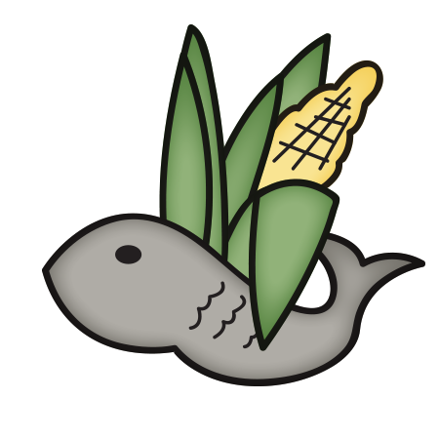
Small Wonders has additional options daily for snack such as:
- Yogurt
- Fresh Fruit
- Cheerios, Rice Chex, Corn Chex, Rice Krispies
- Nutrigrain Bars
- Sun Butter and Pita Bread

Child Nutrition
All weekly menus meet the following guidelines based on the USDA nutrition standards for 2015:
- Acceptable calorie range for the age group
- All grains served are whole grains
- <10% of calories from saturated fat
- National sodium guidelines
- Five sub-groups of vegetables offered
- Choices of fruit and vegetables offered daily

