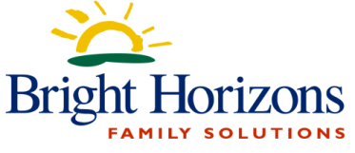
Week 4
Day | Morning Snack | Lunch | Afternoon Snack
Monday | Whole Grain Cereal  Fruit  Milk | Turkey or Ham Sandwiches  Peas  Fruit Cup | Yogurt with  Granola  Water
Tuesday | English Muffins with  Jelly  Milk | Meatloaf  Mashed Potatoes  Corn Fruit | Pita Chips  Cube Cheese  Water
Wednesday | Yogurt and Fruit Salad  Milk  Water | Chicken Nuggets  Mashed Potatoes  Corn  Fresh Berries | Animal Crackers  Fruit  Water
Thursday | Whole Grain Cereal  Fruit  Milk | Chicken Alfredo  Broccoli  Fruit | Trail Mix with  Dried Fruit  Water
Friday | Nutrigrain Bars  Fruit  Milk  Water | BBQ Pulled Chicken  Served on Hawaiian Roll  Caesar Salad  Mandarin Oranges | String Cheese  Mixed Fruit  Water
Milk is served at each of these meals
Whole Milk to Toddlers, Low-fat for Twos, PS, KP
This menu is subject to change without notice due to deliveries and emergencies
Revised 8/22/2022

