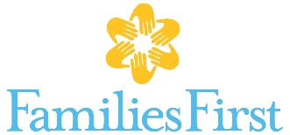 What we’re wishing for….
Volunteer Engagement (Items below are project-specific. Please call 317-644-7237 for details)

- 40-small glass bottles
- Colored sand
- Rice paper
- Gel ink pens
- Chocolate
- Essential oils
- Compact mirrors
- Rice paper
- Bubbles
- Journals
- Small gift bags (all one color)
- Stress balls

Father Engagement program
- Baby gates
- Adult bicycles
- Car seats and booster seats
- Gift cards for transportation: Uber, Lyft, gas, weekly or 30-day IndyGo bus pass
- Gift cards for kid-friendly restaurants, ice cream, etc.
- Passes to kid-friendly entertainment for supervised visitation: 2 adults plus at least 1 child to zoo, Conner Prairie, Children’s Museum, swim parks etc.

Domestic Violence & Family Counseling
- Snacks for adult program groups
Parent education, Parent Café
- Post-It Self-Stick Easel Pad
- Disposable cups, plates, forks, tablecloths
- Reusable bowls, cups, sippy cups
- Toys – toddler age
- Board games – ages 6-12
- Lysol spray
- Coloring pages for Adults; crayons, markers, small playdough
Domestic violence and sexual assault programs
- Legal services for clients – particularly family-law
- Snacks for children’s groups and one-on-one counseling
- Craft items for adults and children

Homebased family preservation
- Baby gates
- Source material – up-to-date, evidence-based worksheets, workbooks, games
- Gift cards for kid-friendly restaurants, ice cream, etc.
- Gift cards for transportation: Uber, Lyft, gas, weekly or 30-day IndyGo bus pass
- Zoo membership

