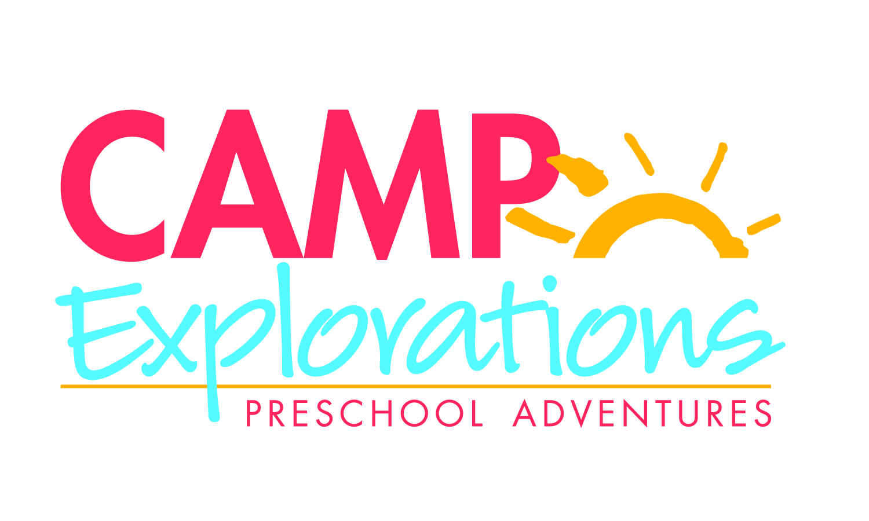

Camper Name:

Address:

Date of Birth: Male/Female:

Are there any allergies we should be aware of?

Parent/Guardian Name:

Home Phone: Business Phone:

Cell Phone:

Part Time/Full Time (please circle): 2 days/week 3 days/week 5 days/week

Please circle the preferred days: M T W TH F

Parent/Guardian Signature:

Please check each session(s) that your child will be attending.
 |  | Dates: | Camp Exploration Theme
◻ | Session 1 | June 3- June 7 | Creative Expressions
◻ | Session 2 | June 10- June 14 | Creative Expressions
◻ | Session 3 | June 17- June 21 | Creative Expressions
◻ | Session 4 | June 24- June 28 | Creative Expressions
◻ | Session 5 | July – July 5, CLOSED 7/4 | Creative Expressions
◻ | Session 6 | July 8 – July 12 | Creative Expressions
◻ | Session 7 | July 15 – July 19 | STEAM Works
◻ | Session 8 | July 22- July 26 | STEAM Works
◻ | Session 9 | July 29 – August 2 | STEAM Works
◻ | Session 10 | August 5 – August 9 | STEAM Works
◻ | Session 11 | August 12- August 16 | STEAM Works
◻ | Session 12 | August 19- August 23 | STEAM Works
◻ | Session 13 | August 26- August 30 | STEAM Works

Bright Horizons at Lakeview
2840 North Lincoln Avenue
Chicago, IL 60657
773-935-7300

To register your child for our summer camp program, please return this completed form
Along with the non-refundable registration fee of $50.00

Please make checks payable to: “Bright Horizons”

