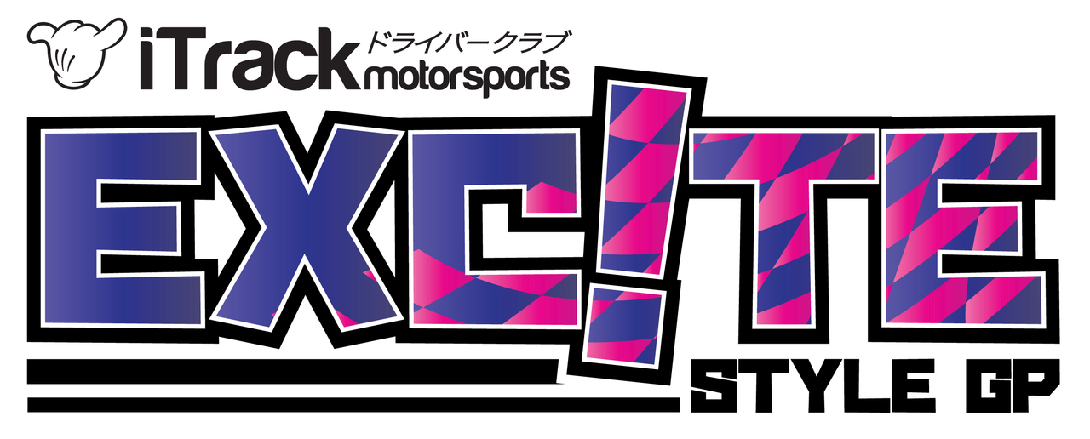

iTrack Motorsports Excite GP 2018 Rules
Table of Contents:
Overview
Page 2
Driver Requirements
Page 3
Vehicle Requirements
Page 4
Competition Format
Page 5
Track Rules
Page 7

Overview
iTrack Motorsports Exc!te GP 2018 Rules
iTrack Motorsports Excite GP was created for drivers of all skill levels to compete in a fun and friendly competition series. This series is designed to not only offer maximum seat time but to give drivers an event format that focuses on perfecting the art of tandem drifting.
All Exc!te GP events are open to drivers of all skill levels. Events will showcase the best in style and speed from the southeast. While all competition series in the southeast provide top level Pro-Am competition for top level drivers, Excite GP offers a grassroots competition for drivers who are style focused. Less about all out power and performance and more focus on style and design.
The three event format will put drivers in a leader board format that awards points and prizes for performance per event. At the end of the three event series the top driver who scores the most points during the season will be awarded the championship trophy that will stay with the champion driver for the duration of the following year.

Sponsors
BridgeMoto
OTP Automotive
Best Damn Shop Around

Driver Requirements
iTrack Motorsports Exc!te GP 2018 Rules

Driver Eligibility
- Drivers must carry a valid state issued drivers license
- No driver competing in Formula Drift in 2018 or Top 8 in point in FD Licensing Pro-Am Series will be eligible for competition in their competition car. Drivers with these titles will be allowed to drive a “street car” which will be determined by the series. (contact for eligibility)
- All drivers must be of 18 years of age or older
- Drivers of all skill levels are encouraged to participate.

Driver Safety Requirements
- SA2010 or new helmet is mandatory for all drivers
- Drivers must wear a minimum of 3 point safety belt at all times on track
- Closed toed shoes and long pants are required
- No driver may be under the influence of alcohol or drugs during any portion of the day.

Vehicle Requirements
iTrack Motorsports Exc!te GP 2018 Rules

Vehicle Eligibility
- Vehicles currently entered in FD Pro series in 2018 competition are not allowed.
- Cages are highly recommended but not mandatory.
- All cars must pass technical inspection prior to first session
- Cars must be free of leaking fluids
- All lug nuts/bolts must be present and tight
- Rear tire tread wear is limited to 240TW and higher. Front tires are open
- All cars should be built within the spirit of the rules. (This isn’t really a rule but stay away from the crazy dog box, 800hp, etc. type builds)
- All cars must follow the iTrack Motorsports general rules (located on www.itrackms.com)
- No severe body damage can be present. All cars must have all body work at the start of driving (only exception is damages in practice)
- Batteries must be securely fastened with OEM or aftermarket mounts. (no straps). Cover must be over positive terminal.

Competition Format
iTrack Motorsports Exc!te GP 2018 Rules
All drivers will be required to attend the morning drivers meeting. Any driver who fails to attend the drivers meeting will not be eligible for Top 16 competition.

Qualifying/Practice
Exc!te GP will use an open lapping format for practice and qualifying. Instead of having a set number of runs to qualify, judges will be selecting the best 16 drivers to run the Top 16 competition event.
- All drivers are given equal seat time. All sessions are considered qualifying runs
- Top 16 drivers will be selected after the final intermediate session
- Top 16 drivers will be selected by performance. Driver Top 16 pairing will be selected at random

Top 16 Competition
Drivers will line up according to random pairing of drivers. Battles will be completed in order of lining up. It is mandatory that all drivers follow pairing by iTrack staff.
- It is mandatory for all Top 16 drivers to be present during announcement of drivers and drivers meeting
- Lead follow runs will be pairing in no particular order
- Drivers will be allowed one tire change during competition. Only driver who have competed in “one more time” battles may have an additional tire change.

Competition Format Continued
iTrack Motorsports Exc!te GP 2018 Rules
- “One more time” calls will only be used when both drivers fail to score during runs
- All calls are final and official
- Judging will score on the overall performance of the run. This includes but is not limited to speed, line, style, angle, and proximity.
- If a start is jumped or an error is made prior to the start of judge zone, a red flag will be given and a restart can be taken
- All drivers will be allowed to work on their car while waiting for next round
- 5 minute mechanical break may only be given once and may not be used during one more time. (exception: both cars are damaged during first run)
- If a driver hits a barrier during competition, they will automatically score a ZERO for that run. If a driver has 2 or more wheels go off course they will score a ZERO.

Payouts and prizes
First Place (1st) - $200.00 cash prize
Second Place (2nd) - $100.00 cash prize and trophy
Third Place (3rd) - $50.00 cash prize and trophy
Big Entry – Exc!te GP t-shirt
Top Novice – Exc!te GP t-shirt
Best Event Promoter – OTP Automotive tool bag, high performance fluids, and tools

Track Rules
iTrack Motorsports Exc!te GP 2018 Rules
- All drivers must respect the rules of the track and its staff
- All drivers must arrive on time
- All drivers must follow all flag signals
- No race engines can be run between 10-12PM on Sundays due to county law (Lanier Raceplex only)
- Damages to barriers beyond repair will be $100.00 per barrier (Lanier Raceplex only)
- No standing burnouts can be made prior to competition run. Warm up Figure 8’s and scrubbing fronts is allowed prior to first lead/follow. No scrubbing or warming tires will be allowed after first run.
- No burnouts in the paddock or standing burnout on track
- No drifting on corded tires
- Illegal drugs, weapons, explosives, etc will not be allowed on the premises
- All pets must be on a leash
- All trash must be placed in a trash can around the track. All tires must be taken home with the driver.
All questions regarding series rules must be forwarded to itrackmotorsports@gmail.com. All rules are subject to change.

