 | MONDAY | TUESDAY | WEDNESDAY | THURSDAY | FRIDAY
WEEK 1  10/03 – 10/07 | AM: Cereal with Milk  PM: Nutri Grain with Milk | AM: Blueberry Muffins and Milk  PM: Teddy Grahams | AM: Waffles with Syrup  PM: Animal Crackers and Milk | AM: GoGo Squeez Yogurt with Crackers  PM: Cheese Sticks and Crackers | AM: English Muffins and Jelly  PM: Fruit Cup and Crackers
WEEK 2  10/10 – 10/14 | AM: Cinnamon Raisin Bagel with Cream Cheese  PM: Bananas with Crackers | AM: Cereal with Milk  PM: Cheese Sticks with Wheat Wafers | AM: Blueberry Muffins with Milk  PM: Fruit Cup and Graham Crackers | AM: Waffles with Syrup  PM: Applesauce with Graham Crackers | AM: GoGo Squeez Yogurt with Vanila Wafers  PM: Blueberry Lemon Crispy Bites
WEEK 3  10/17 – 10/21 | AM: Cereal with Milk  PM: Pita Pocket with Sunbutter | AM: English Muffin with Jelly  PM: Animal Crackers with Milk | AM: Nutri Grain Bar and Milk  PM: Fruit Yogurt and Granola | AM: Blueberry Muffin and Milk  PM: Teddy Grahams and Milk  d Wheat Crackers | AM: Bananas with Vanilla Wafers  PM: Rice Cakes with Milk
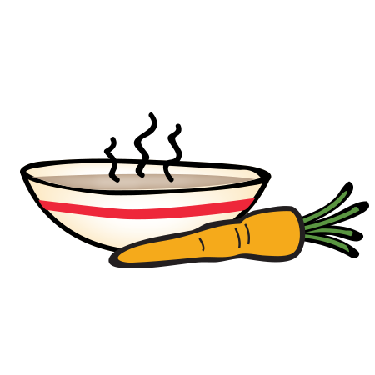
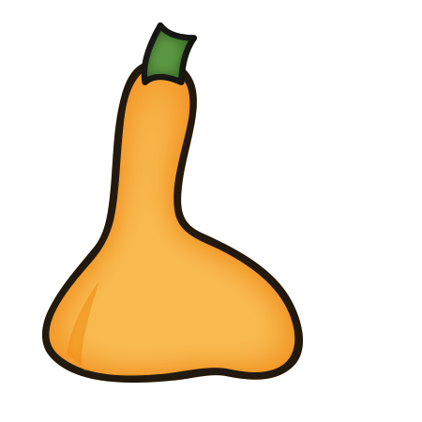
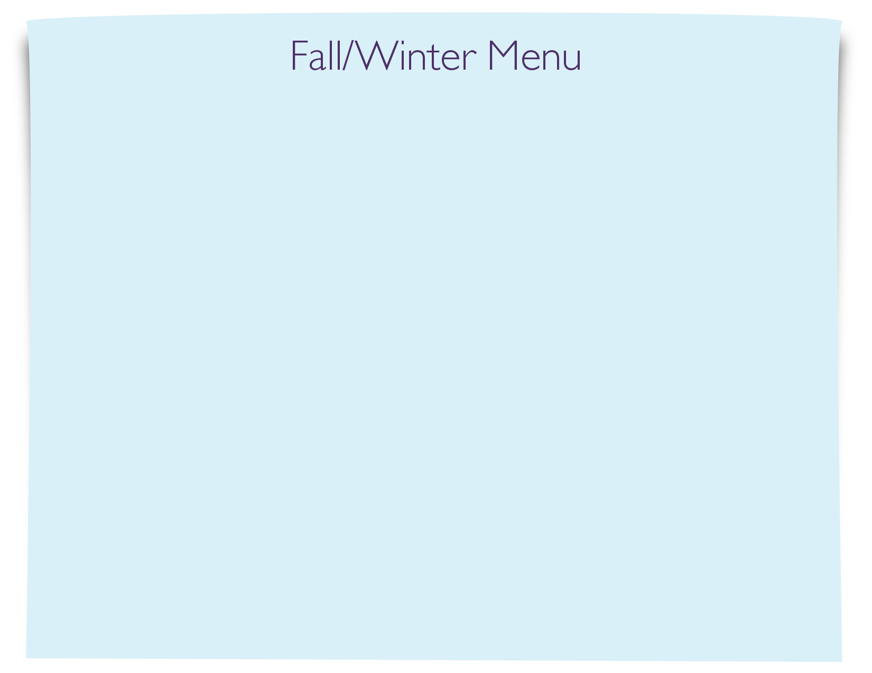
Snack Menu

