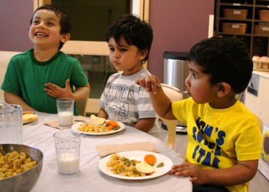
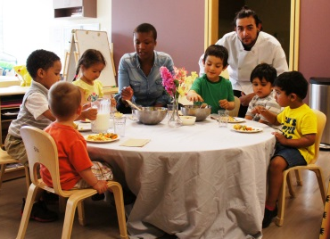
Bright Horizons at the Y
Weekly Menu (3)
May 7th – May 11th

 | Monday | Tuesday | Wednesday | Thursday | Friday
Breakfast | WW English Muffins  Mandarin Oranges  Milk | Cereal  Peaches  Milk | Apple Cinnamon Muffin  Banana  Milk | Oatmeal  Pineapple  Milk | Raisin Toast  Blueberries  Milk | Meet our Cook Ms. Maria  Wisconsin State Certified  Partnership for Healthier America Nutrition and Meal Guidelines Trained  Chef Phillip
10:00 am Snack  (Transition, Preschool, Kindergarten Prep Classrooms Only) | Graham Crackers  Water | Graham Crackers  Water | Graham Crackers  Water | Graham Crackers  Water | Graham Crackers  Water
Lunch | Grilled Cheese  Tomato Soup  Banana  Milk | Turkey with Gravy  Brown Rice  Vegetable Blend  Strawberries  Milk | Baked Chicken  WW Noodles  Zucchini and Tomatoes  Mixed Fruit  Milk | Diced Ham, Potato, Cheese Casserole  Green Beans  Pears  Milk | Sloppy Joes  WW Bun  Mixed Vegetables  Mixed Berries  Milk
Vegetarian Substitute | Grilled Cheese | Veggie Strips | Veggie Patty | Cheese Potato Casserole | BBQ Veggie Crumbles
Afternoon Snack | Dried Fruit  String Cheese | Yogurt  Banana | Cottage Cheese  Blueberries | WW Crackers  Hard Boiled Egg | Nutri-Grain Bar  Peaches
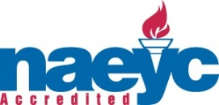
Healthy Meals
- Vegetarian Meal Options.
- Fresh Fruits and Vegetables Served Every Day.
- All Raw Vegetables are cooked for children under the age of 3 years.
- All Meals are Baked Not Fried.
- Proteins Include Chicken, Turkey, Beef, Tofu, Cheese and Beans.
- Whole Milk Served to Infants and Toddlers.
- 1% Milk Served to Young Preschool, Preschool and Kindergarten Prep.
- Evening Snack is provided in the lobby every day.
- All Meals are Included in the Tuition.
- All Meals are Served Family Style.

!

I/T: Infant/Toddler Alternative
V: Vegetarian Alternative

