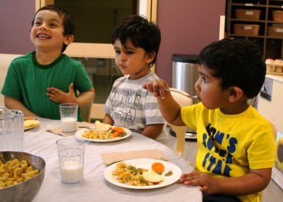
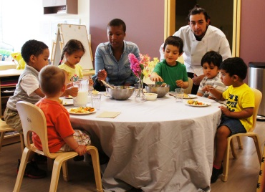
Bright Horizons at the Y
Weekly Menu
Sample

 | Monday | Tuesday | Wednesday | Thursday | Friday
Breakfast | WW Bagel  Pineapple  Milk | WW Toast  Peaches  Milk | Chex  Pears  Milk | Oatmeal  Mixed Berries  Milk | Muffins  Mandarin Oranges  Milk | Meet our Cook Mr. Charles  Wisconsin State Certified  Partnership for Healthier America Nutrition and Meal Guidelines Trained  Chef Phillip
10:00 am Snack  (Transition, Preschool, Kindergarten Prep Classrooms Only) | Graham Crackers  Water | Graham Crackers  Water | Graham Crackers  Water | Graham Crackers  Water | Graham Crackers  Water
Lunch | Beef and cheese enchiladas  Japanese mix  Applesauce  Milk | Turkey and Cheese Wrap  Carrot Sticks  Mixed fruit  Milk | Cheese English Muffin  Pizza  Cauliflower  Pineapple  Milk | Mac-N-Cheese  Diced Ham  Broccoli  Peaches  Milk | BBQ Meatballs  Noodles  Mixed Vegetables  Pears  Milk
Vegetarian Substitute | Veggie Patty | Cheese Wrap | Cheese English Muffin | Mac-N-Cheese | BBQ Veggie Crumbles
Afternoon Snack | Cereal Mix  Apples | String Cheese  Crackers | Muffins  Strawberries | Yogurt Parfait with Granola and Blueberries | Nutri-grain  Applesauce
Healthy Meals
- Vegetarian Meal Options.
- Fresh Fruits and Vegetables Served Every Day.
- All Raw Vegetables are cooked for children under the age of 3 years.
- All Meals are Baked Not Fried.
- Proteins Include Chicken, Turkey, Beef, Tofu, Cheese and Beans.
- Whole Milk Served to Infants and Toddlers.
- 1% Milk Served to Young Preschool, Preschool and Kindergarten Prep.
- Evening Snack is provided in the lobby every day.
- All Meals are Included in the Tuition.
- All Meals are Served Family Style.

!

I/T: Infant/Toddler Alternative
V: Vegetarian Alternative

