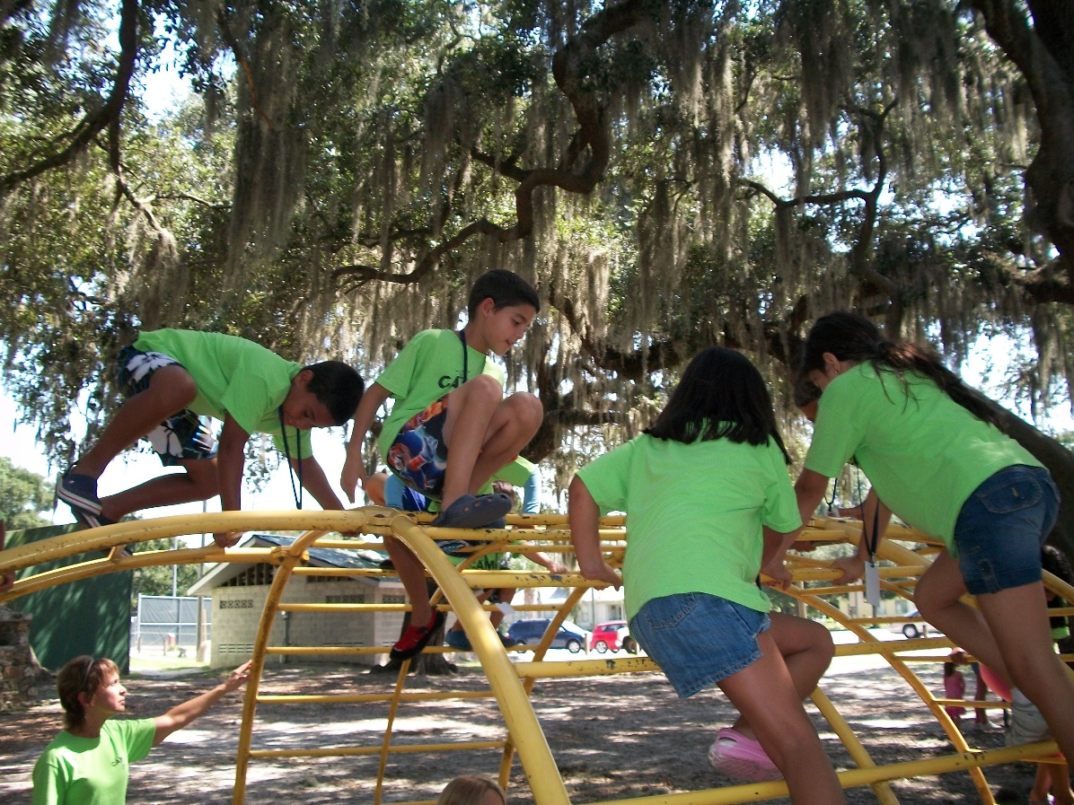

Through Camp Explorations, our summer camp program at **The Citi Family Center**, your child will have the opportunity to enjoy everything summer has to offer. During action-packed days, your child will experiment with science and technology, engage in the creative arts, discover nature, and explore the world. With experienced teachers, a curriculum based on each child’s interests, engaging projects and activities, special visitors, and more, summer will be fun and educational at the same time.

­­­

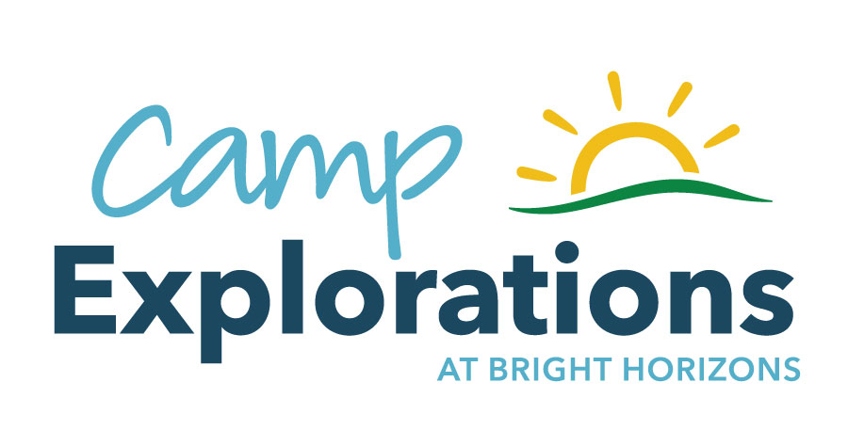

Bright Horizons at Citi Family Center

3701 Queen Palm Drive  
Tampa, FL, 33610 | 813-604-6142

ctb.ta@brighthorizons.com | www.brighthorizons.com/Center/Cititampa

**Camp Explorations Highlights**

* Programs for two different age groups:
  + Preschool Adventures (ages 3 – 5)
  + School-Age Adventures (ages 6 –12)
* Age-appropriate, engaging themes that incorporate children’s interests
* Field trips, special guests, and daily fitness activities
* Full time enrollment and Some back up care based on space availability
* Health, safety, and security policies that meet or exceed local, state, and national standards