**From the Director**

Hello Adams St. Families –

It is hard to believe that February has come and gone already! Thank you to everyone that participated in the Parent Satisfaction Survey. Once we receive the results we will be sharing an action plan that will detail how we can continue to succeed and address areas for improvement.

The Awards of Excellence nominations are being accepted through Friday, March 2nd. Please visit [www.brighthorizons.com/awards](http://www.brighthorizons.com/awards) to nominate a teacher who has made your Bright Horizons experience great! We will have a banquet in May where we will recognize and celebrate all of our teachers.

I invite all of you to join our Family Partnership Group Meeting on March 13th at 12:00 pm. We will be asking for specific feedback on how these meetings are held, as well as other forms of communication. Additionally, Ms. Melony will host our first monthly Parent Workshop on March 20th. Details with log-in access will be sent out in the weekly memos.

We encourage all families to please speak with myself or Ms. Melony with any concerns or questions that you may have. This will allow us to address them in a timely, accurate manner.

Thank you

TJ McNamara

Executive Director

2018 | March Newsletter

Bright Horizons at   
Adams Street News

Important Dates

March 13th: Family Partnership Group Meeting

March 17th: St. Patrick’s Day

March 20th: Parent Workshop

March 30th: Reregistration letters go out to families

April 2nd – April 6th: Scholastic Book Fair

April 5th: Summer Camp Preview Day

April 27th: Reregistration Agreements Due

Happy Birthday!

Sonali T. – March 2nd

Owen L. – March 4th

Graham D. – March 5th

Reese D. – March 12th

Lucas P.R. – March 16th

Riley W. – March 16th

Mae K. – March 18th

Pinchas M. – March 20th

Everly R. – March 22nd

Ruby D. – March 29th

Maxine C. – March 31st

****Bright Horizons at Adams St.****

345 Adams St. Brooklyn, NY 11201

(718) 488-7770 | [adamsstreet@brighthorizons.com](mailto:adamsstreet@brighthorizons.com)

Monday – Friday 7:00 am – 6:30 pm

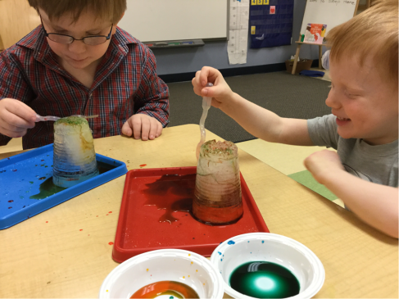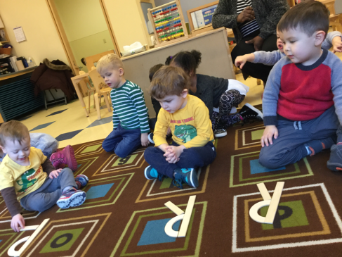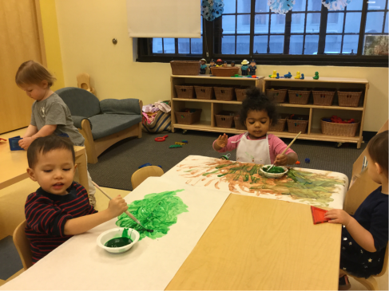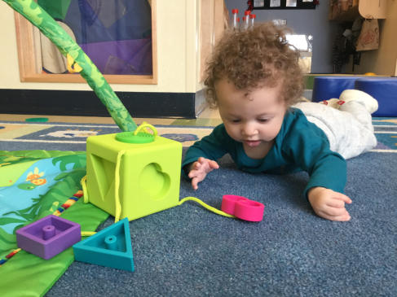

Math Counts

Mathematical concepts are indeed an important part of an Infant’s early learning. As an Infant gazes intently at the geometric shapes and patterns of a toy, she is experimenting with the earliest concepts of math. We learn to match an appropriate block to the correct shape on a toy by experimenting with placing blocks in shape boxes or pieces in simple puzzles.

Art Smart

Early learning experiences infused with art not only nurture creative and artistic growth, but also enhance development in other areas including literacy, math, and science. We learn to investigate the world through our senses, experiment with and explore color, and make deliberate markings or drawings. We learn this by exploring materials that engage the senses, expressing creativity in our own way, and using developmentally appropriate art materials.

Language Works

Through this curriculum, teachers provide children with opportunities to integrate listening, speaking, reading, and writing into daily activities within the classroom. We begin to recognize, create, and purposefully make letters. We do this by using materials, such as Handwriting Without Tears, to create letters.

Science Rocks

Science Rocks engages Kindergarten Prep children in meaningful scientific learning. At Bright Horizons, we examine, describe, compare, and contrast the physical properties of objects and materials and explore how properties change. We do this by participating in projects that alter physical properties and offering hypothesis, predictions, planning investigations, and drawing conclusions.

CLASSROOM HIGHLIGHTS

Have you considered gathering on a regularly designated evening to play games? Interactive family activities foster growth in all domains of development, but more importantly, having fun as a family promotes bonding and intimacy, builds trust, instills a sense of security, teaches children about winning and losing, and creates lifelong memories.

Tips for family game nights:

* Schedule a regular day and time. Reserve it as you would any important activity.
* Plan games that are appropriate for varied age groups. Include children in the decision making.
* Eliminate distractions. Turn off cell phones and other devices.
* Focus on fun!

**The benefits:**

Playing board games helps children learn to take turns, follow rules, and think strategically. Many board games strengthen focus and literacy and math skills. Moving pieces along a board, holding cards, rolling dice, or spinning a spinner builds small muscle development and hand-eye coordination.

**Choosing Games**

Selecting games can be an enjoyable process. Game suggestions to check out are *Apples to Apples Junior*; *Don’t Wake Daddy*; *Alphabet*, Number or Color Bingo; Dr. Seuss’ the Cat in the Hat; *I Can Do That!;* and *Guess Who*. Games such as BANANA GRAMS offer challenge for many ages. For young children, look for games that are colorful, engaging, and take less than 20 minutes to play. Those that focus on cooperation, rather than competition, are also a good choice.

Make a homemade “memory” game by copying family photos on cardstock and laminating the cards. Turn chores into a game, e.g., let your young child match socks or toss the socks into a laundry basket. Get the whole family moving with action games. Try Charades, *Twister*, Hide and Seek, *Sardines*, Freeze Tag, Red Light, Green Light, or Mother May I.

Game night is about families being together. It doesn’t have to cost money, but the gains are tremendous because ultimately, everyone wins!



Everyone Wins at Family Game Night!

Ready for school News

We are hosting an Open House in April!

Bright Horizons NEWs

Next month, we will be hosting an Open House Week where new families will be able to discover why Bright Horizons is the perfect place for children to learn, explore, and grow!

Each year, Bright Horizons welcomes new families to our community. And, year after year, we’ve found that the best way to meet these families is through you.

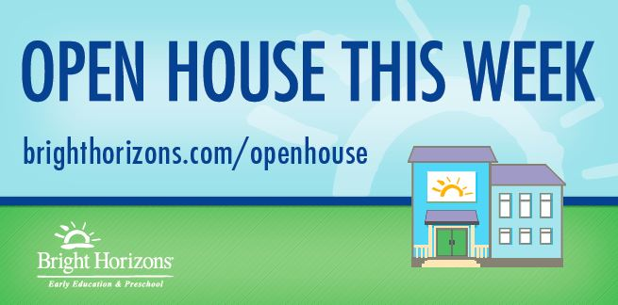

If you have a friend or family member that might be interested in joining, we would be happy to provide information for you to share with them. Please see your Center Director for details. We hope to see everyone at Open House Week!

Join us for a summer of fun,   
friendships, and exploration!

Summer is less than 6 months away! Our two summer camp programs, *Camp Explorations: Preschool Adventures* (ages 3-5) and *Camp Explorations: School-Age Adventures* for school age (ages 6-12), take advantage of everything summer has to offer.

Our teachers develop a fun curriculum that uses surrounding communities and special visitors as an extension of the camp and integrate technology throughout the programs. Children learn about the world around them while exploring nature, experimenting with science, and engaging in creative arts.

To learn more about summer camp programs at your center, talk to your center director. Programs vary by location.

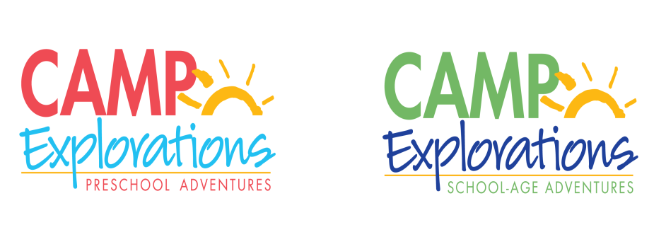



Check out all the places you can connect with us!

