 | MONDAY | TUESDAY | WEDNESDAY | THURSDAY | FRIDAY
WEEK 1  07/11-07/15 | AM: Wheat Bagel with Cream Cheese  PM: Rice Cakes with Milk | AM: English Muffins with Cream Cheese or Jelly  PM: Fruit Yogurt and Granola | AM: Cinnamon Bagel with Cream Cheese  PM: Animal Crackers and Milk | AM: Biscuit with Jelly  PM: Applesauce and Graham Crackers | AM: Naan Bread and Sun Butter  PM: Nutri Grain Bar and Milk
WEEK 2  07/18-07/22 | AM: English Muffins with Jelly  PM: Applesauce and Graham Crackers | AM: Cereal with Milk  PM: Rice Cakes with Milk | AM: Naan Bread and Sun Butter  PM: Fruit Cup and Crackers | AM: Fruit Yogurt and Granola  PM: Nutri Grain Bar and Milk | AM: Cinnamon Raisin Bagel with Jelly  PM: Teddy Grahams and Milk
WEEK 3  07/25-07/29 | AM: Cereal with Milk  PM: Animal Crackers with Milk | AM: Biscuits and jelly  PM: Naan Bread and Sun Butter | AM: English Muffins and Jelly  PM: Fruit Yogurt and Granola | AM: Cinnamon Raisin Bagel with Cream Cheese  PM: Teddy Grahams and Milk  d Wheat Crackers | AM: Nutri Grain Bar with Milk  PM: Rice Cakes with Milk
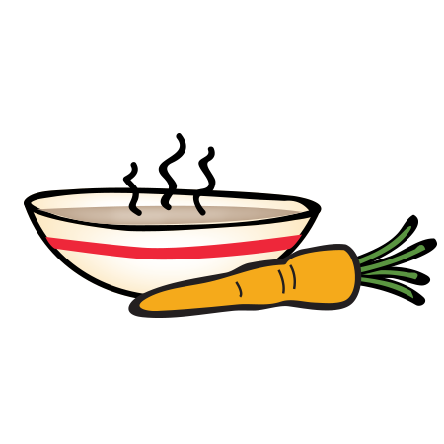
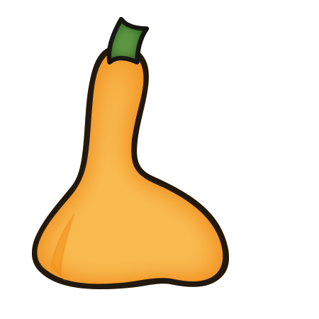
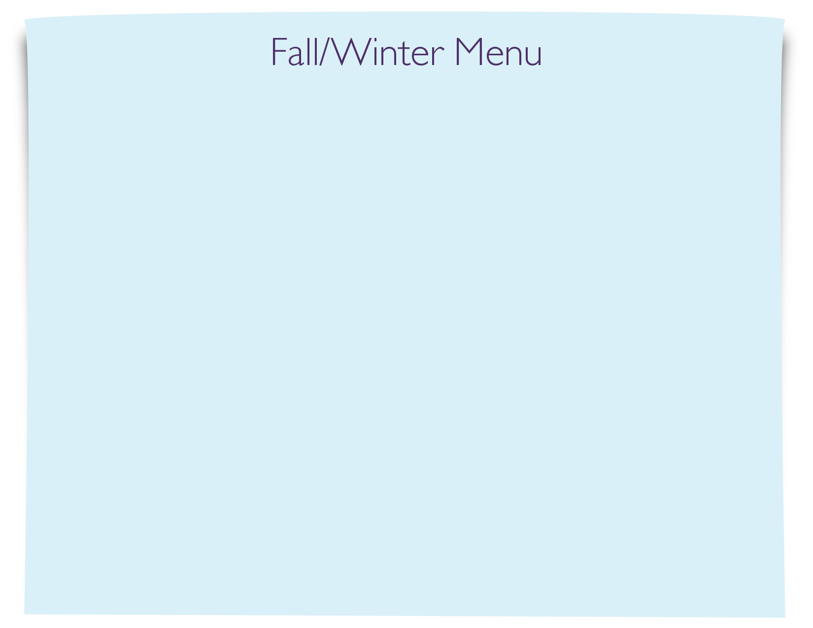
Snack Menu

