Updating Internet Explorer to support TLS 1.2
Many versions of Internet Explorer can support TLS 1.2, but do not do so by default.

If you are using a version of Internet Explorer that does not support TLS 1.2, rather than seeing the test site, you will see an error message instead.

You can successfully connect to TLS 1.2 if you see the following screen (you do NOT need to log in):
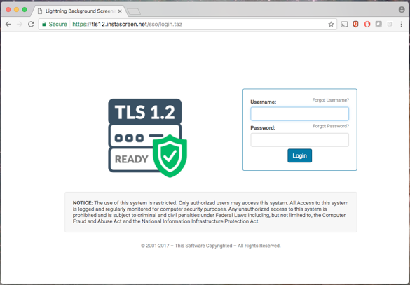

If you see this screen instead, you will no longer be able to access our software after we drop support for TLS 1.0 and 1.1:
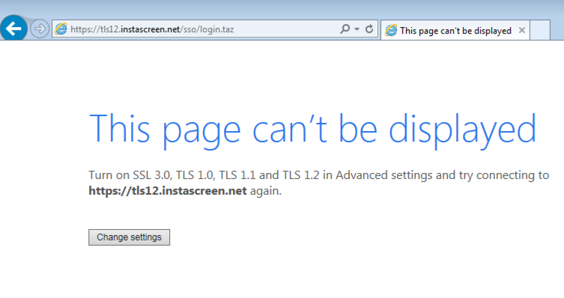

Updating your browser
The most important step is to update your browser if you are not already using Internet Explorer 11 or Edge, as Microsoft itself has discontinued support for all earlier versions of Internet Explorer, and many websites, including ours, also do not support these older versions.

To make sure you are using the most updated version of Internet Explorer, click the gear icon in the top right corner of your browser (right below the big red X to close the window), then scroll down to About Internet Explorer at the very bottom.

Check the box to “Install new versions automatically,” and then click close.

This will make sure your browser version is always current so you do not have to worry about future updates.

Turning on TLS 1.2 support
If updating your browser does not resolve the problem (or if you are already on a current version of Internet Explorer), you can manually turn on TLS 1.2 support.

To update, you simply need to go to the gear menu in the top right corner, select Internet Options (close to the bottom of the list), and then scroll down until you see “Use TLS 1.2.” Make sure this checkbox is turned on, then save your settings.

You do not need to remove support for TLS 1.0 or 1.1, as long as you have TLS 1.2 turned on.
