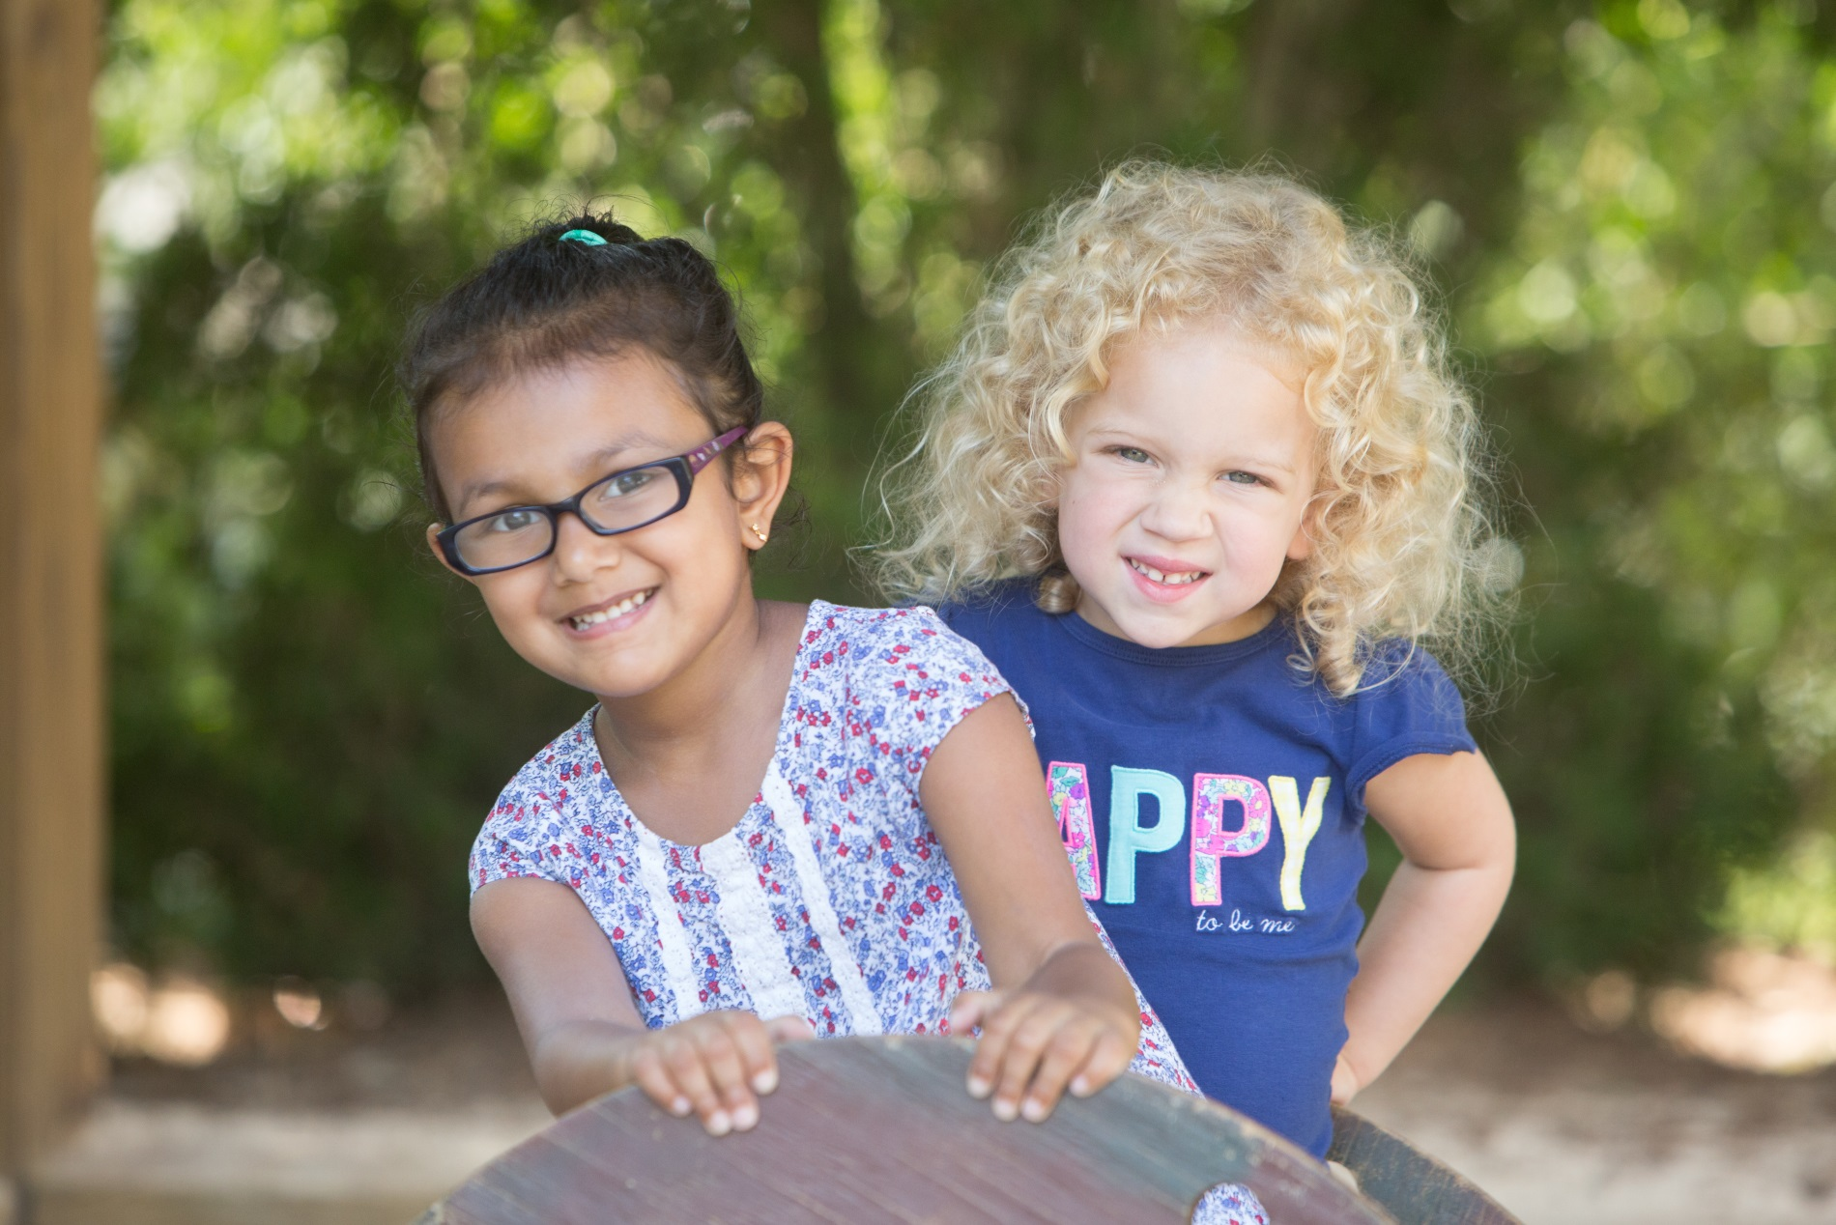

Through Camp Explorations, our summer camp program at **Bright Horizons**®, your child will have the opportunity to enjoy everything summer has to offer. During action-packed days, your child will experiment with science and technology, engage in the creative arts, discover nature, and explore the world. With experienced teachers, a curriculum based on each child’s interests, engaging projects and activities, special visitors, and more, summer will be fun and educational at the same time.

Bright Horizons at Fourth and Madison

925 Fourth Avenue Suite 200  
Seattle, WA, 98104 Zip | 206.381.9904

fourthandmadison@brighthorizons.com | brighthorizons.com/fourthandmadison

**Camp Explorations Highlights**

* Programs for two different age groups:
  + Preschool Adventures (ages 3 – 4)
  + Kindergarten Prep Adventures (ages 4 – 5)
* Age-appropriate, engaging themes that incorporate children’s interests
* Special guests, and daily fitness activities
* Flexible weekly schedules with full- and part-time options
* Health, safety, and security policies that meet or exceed local, state, and national standards