CENTER LOCKS
This only applies to vehicles equipped with street legal Center Lock (CL) wheels;
The participant while your vehicle is in Safety Tech we will also inspect your vehicle for a Center Lock (CL) inspection. This procedure does not include factory race vehicles.
BACKGROUND:
We routinely have issues regarding the CL locking mechanism being properly engaged. At virtually every event we have one or more CL cars that have been tech inspected at their dealers or other reputable automobile repair shops, but a quick visual inspection indicates that the CL “locking mechanism” is not engaged on one or more (occasionally all four) of the CL wheels.
If the locking mechanisms are not engaged then nothing will prevent the single wheel nut from loosening.
We rely on your manufacturer owner’s manual for the description of how to properly torque center lock wheels. Please read and familiarize yourself with these procedures because they are critical to your safety and that of your fellow participants. We do not rely upon any other unpublished bulletin(s).
Therefore, every participant in a PPEA High Performance Driver Education program must submit a completed Tech Inspection Form certifying that their car’s wheel lug nuts have been properly torqued. If you are unsure of your vehicle’s torque, Park Place Certified Technician member are on-site to assist you.
Additionally the cars equipped with CL wheels must undergo a separate procedure to insure the CL’s locking mechanism is properly engaged. The participants vehicle must display a daily CL tech inspection form on their windshields.
Here is a link to a YouTube video showing engagement of the locking device:
https://www.youtube.com/watch?v=wk9ZPQTFXBU
As a part of our safety tech, a member of our tech safety team will inspect your vehicle to make sure the locking mechanism is fully engaged on all 4 wheels.
The procedure:
1. Prior to bringing your vehicle to tech, please remove the center dust cap from your CL Wheel.
2. We will inspect your vehicle to ensure your CL locking mechanism is fully engaged.
3. If your CL locking mechanism is fully engaged, then we will provide you with a daily CL inspection sticker to be place in the appropriate place on your windshield.
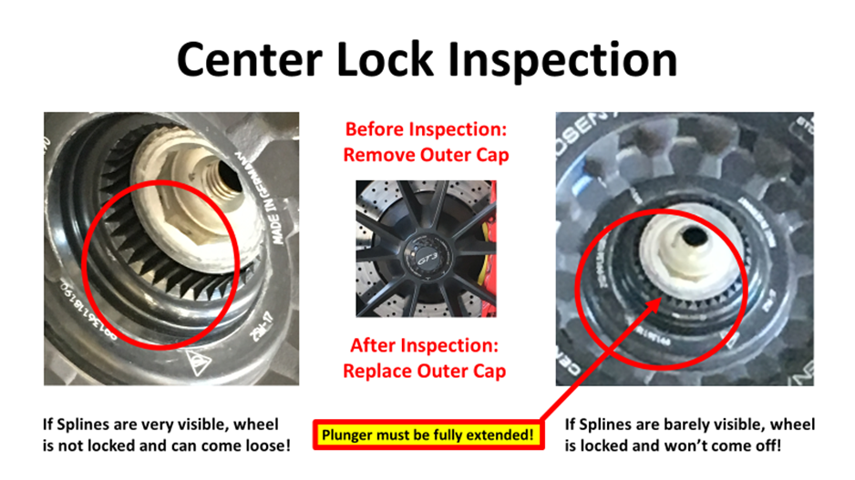
If your vehicle does not pass inspection, then
4. We will provide the participant with a tool that will help you fully engage your CL locking mechanism. We will provide you with instruction on how to do this, but we will NOT do the procedure for you. The participant assumes all the risk.
5. If your CL locking mechanism then is fully engaged, then we will provide you with a daily CL inspection sticker to be place in the appropriate place on your windshield.
NOTE: If you cannot get you CL locking mechanism to fully engage, then we have on-site Park Place certified technician members to support you.
NOTE: Once you receive your CL daily inspection sticker, please remember to replace the center dust caps prior to your 1st run.

We are here to assist the participant:
If you are unfamiliar or unsure of what is required to properly torque your CL wheels then we have Park Place certified technician members on site that will ensure that your vehicle CL’s are torqued properly. Afterwards you or they will engage the CL’s locking mechanism. Remember, a member of our tech safety team will visually confirm the engagement of the locking mechanism, and we will give you a daily CL daily tech inspection sticker.
If you wish to torque your own CL wheels you may do so, but you will still need a visual confirm the engagement of the locking mechanism, and we will give you a daily CL daily tech inspection sticker.
Under no circumstance will a vehicle with CL’s be allow on track without a daily CL inspection sticker attached to the vehicle’s windshield in the proper place.

