PARISH BULLETIN INSERT FOLLOWING THE
CATHOLIC HIGH SCHOOL COLLECTION 2021

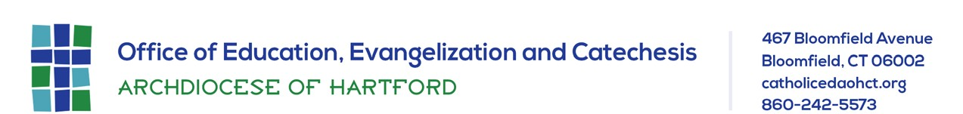

Please place this in your parish bulletin on the weekend of January 30/31, 2021

THANK YOU! The Catholic secondary school students in the Archdiocese of Hartford send their deepest gratitude to all who participated in the 2021 Catholic High School Collection. Your support will enhance the educational excellence of their schools and help them prepare for leadership roles and active lives of faith. We deeply appreciate your support of Catholic high schools as they pursue their mission of education and evangelization.

