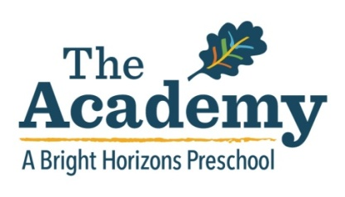

The Academy at Venice is located at 2201 Lincoln Blvd in Venice, California. Three separate buildings situated on the property are surrounded by spacious outdoor areas which make our Venice location extraordinary. This secured campus is sure to provide endless opportunities for on-site exploration and adventures. The 7,000 square feet of combined building areas contain five main classrooms and plenty of additional space for auxiliary learning environments.

How we spend our days…

Drop- off and Freeplay: table activities, dress-up, blocks, art, library
Circle Time: good morning song, calendar, weather, theme-based story, foreign language
Snack: fruits, vegetables, crackers, yogurt, pretzels, cheese
Gross Motor: indoor and outdoor options for teacher and/or child led activities based on expanding energy using large muscle groups
Center Time: activities in art, math/science, language arts,fine/gross motor, sensory table
My Gym: introductory sport skills, gymnastics games, promoting health and fitness
Closing Circle/Music: songs and musical instruments, what we did today discussion...“that’s a wrap”
Free play/Pick-up: dramatic play, manipulative, puzzles

Listed below are dates The Academy will be closed for the 2020 school year:

January 20th MLK Day
February 17th Presidents’ Day
April 6th-10th Spring Break
May 25th Memorial Day
June 29th-July 3rd Summer Break
September 4th Institute Day
September 7th Labor Day
November 11th Veterans’ Day
November 25th-27th Thanksgiving Break
December 18th-January 1st Winter Break

2020 Tuition
Monthly payments due by the 1st of the month

FULL DAY HALF DAY
7:30 am - 5:30 pm 8:30 am - 12:00 pm
2 days $993/month 2 days $767/month
3 days $1335/month 3 days $1076/month
4 days $1682/month 4 days $1380/month
5 days $2035/month 5 days $1689/month

**Monthly tuition is derived from the total number of weeks in the school year and is split into equal monthly payments.
Full payment of monthly tuition is required even if the child is unable to attend due to illness, vacation or school closings.

310-827-7300
www.brighthorizons.com/academy-venice

