February 2020
 | MONDAY | TUESDAY | WEDNESDAY | THURSDAY | FRIDAY
February 3-7 | 3  Cheese Quesadilla  Salsa  Pineapple Tidbits | 4  Chicken Nuggets w/Sweet & Sour Sauce  Cinnamon Mashed Sweet Potatoes  Diced Pears | 5  Hamburger Patty & Whole Grain Bun  Sweet Yellow Corn  Applesauce | 6  Italian Dipper Pierogies  Marinara Cup  BBQ Baked Beans Fresh Mandarins | 7  Deli Sandwich  Buttered Green Beans  Diced Pears
February 10-14 | 10  Cheese Pizza  Broccoli & Cheese  Pineapple Tidbits | 11  Mini Twin Cheeseburgers  Potato Emojis  Diced Pears | 12  Wowich  Cheesy Seasoned Cauliflower  Applesauce | 13  Cherry Blossom Chicken and Veggie Fried Rice  Seasoned Edamame  Fresh Mandarins | 14  Toasted Cheese  Sweet Potato Waffle Fries  Diced Pears
February 17-21 | 17  Small Wonders Closed | 18  Chicken & Waffles  Cinnamon Mashed Sweet Potatoes  Diced Pears | 19  Hamburger Patty & Whole Grain Bun  BBQ Baked Beans  Applesauce | 20  Walking Taco  Reduced Fat Tostito’s  Sweet Yellow Corn  Fresh Mandarins | 21  Deli Sandwich  Buttered Green Beans  Diced Pears
February 24-28 | 24  Breaded Ravioli  Marinara Cup  Sweet Yellow Corn  Pineapple Tidbits | 25  Salisbury Steak & Gravy with Mashed Potatoes  Dinner Roll  Diced Pears | 26  Cheese Pizza  Cucumber Moons  Applesauce | 27  Toasted Cheese  Seasoned Broccoli  Fresh Mandarins | 28  Wowich  Sweet Potato Fries  Diced Pears

February 2020 Snack Menu
 | MONDAY | TUESDAY | WEDNESDAY | THURSDAY | FRIDAY
Menu items are subject to change without notification | Whole Grain Soft Pretzel & Milk | Whole Grain Mini Muffin Loaf & Applesauce | Yogurt & Fresh Fruit | Whole Grain Granola Bar & Milk | String Cheese & Honey Graham Crackers
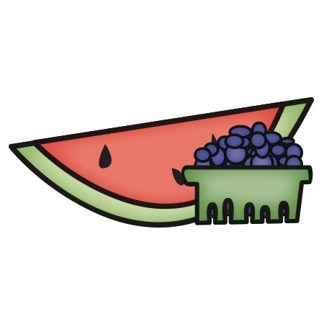
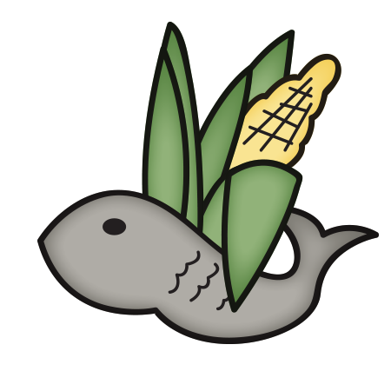
Small Wonders has additional options daily for snack such as:
- Yogurt
- Fresh Fruit
- Cheerios, Rice Chex, Corn Chex, Rice Krispies
- Nutrigrain Bars
- Sun Butter and Pita Bread

Child Nutrition
All weekly menus meet the following guidelines based on the USDA nutrition standards for 2015:
- Acceptable calorie range for the age group
- All grains served are whole grains
- <10% of calories from saturated fat
- National sodium guidelines
- Five sub-groups of vegetables offered
- Choices of fruit and vegetables offered daily

