 | MONDAY | TUESDAY | WEDNESDAY | THURSDAY | FRIDAY
WEEK 1  9/28- 10/2 | AM: Cereal with milk  PM: Rice cakes | AM: Bagel with cream cheese  PM: Fresh fruit and cheddar crackers | AM: Vanilla Yogurt and granola  PM: Naan Bread and sun butter | AM: Biscuits and Jelly  PM: Applesauce and sweet potato crackers | AM: Blueberry Muffin with milk  PM: Cheddar cheese and Ranch wheat crackers
WEEK 2  10/5- 10/9 | AM: Nutrigrain bar with milk  PM: Applesauce and graham crackers | AM: Cereal with milk  PM: Fresh fruit and wheat wafers | AM: Cinnamon raisin bread with jelly  PM: Animal crackers with milk | AM: Fruit Yogurt and Graham crackers  PM: String cheese and oyster crackers | AM: Banana Muffin with milk  PM: Fruit cup with cheddar crackers
WEEK 3  10/12- 10/16 | AM: Cereal with milk  PM: Rice cakes | AM: Biscuits and jelly  PM: Naan Bread and sun butter | AM: Apple Cinnamon muffin with milk  PM: Fresh Fruit with ranch wheat crackers | AM: Bagel with cream cheese  PM: Cheddar cheese and wheat crackers | AM: Vanilla Yogurt and granola  PM: Applesauce and sweet potato crackers
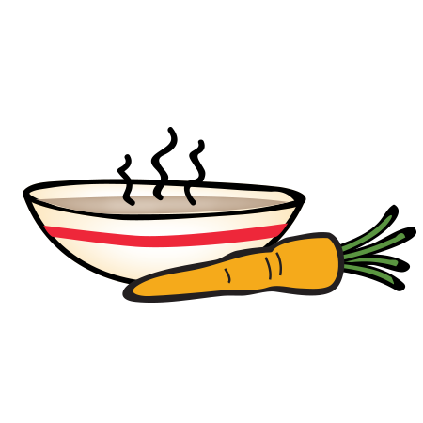
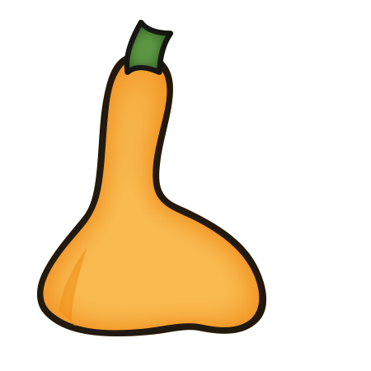
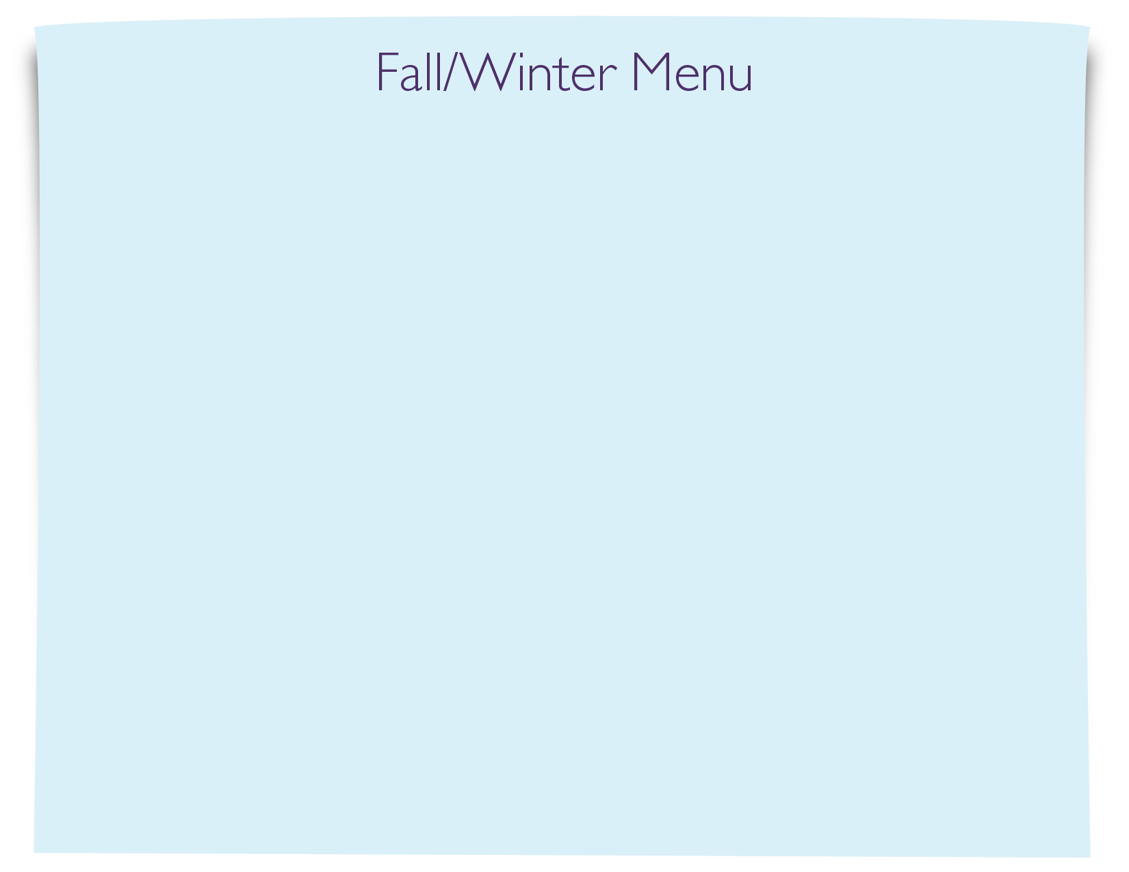
Snack Menu

