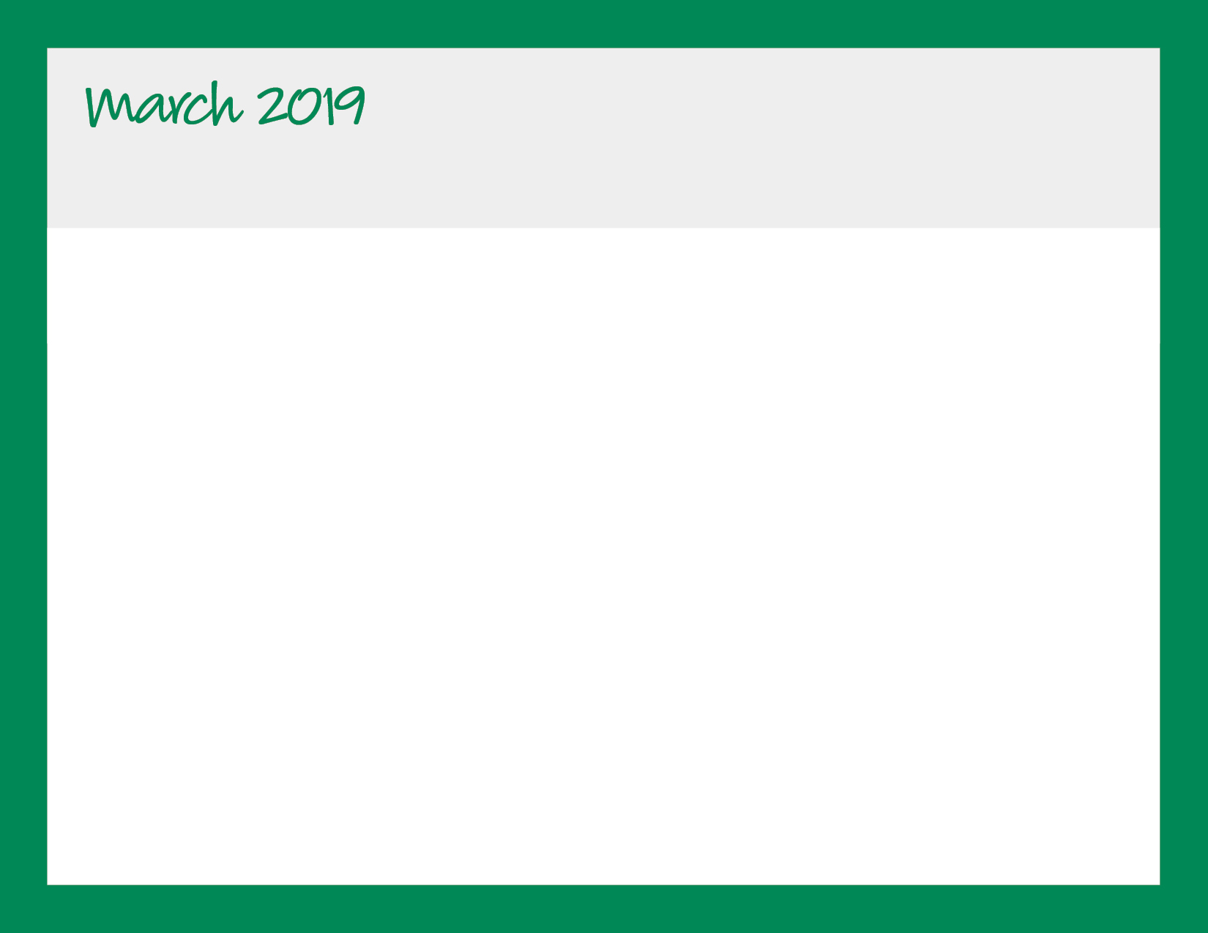

|  |  |  |  |  |
| --- | --- | --- | --- | --- |
| **Monday** | **Tuesday** | **Wednesday** | **Thursday** | **Friday** |
|  |  |  |  | 1  Pizza by Papa John |
| 4  Baked Chicken Nuggets, Roatsed Seasonal Veggies, Fresh Fruit | 5  Pasta w/Tomato Sauce, Roasted Seasonal Veggies, Fresh Fruit | 6  Chicken w/Sauteed Mushroom Sauce, Roll, Roasted Veggies, Fresh Fruit | 7  Lean Beef Meatballs w/Tomato Sauce, Roasted Veggies, Roll, Fresh Fruit | 8  Pizza by Papa John |
| 11 Baked Chicken Nuggets, Roasted Seasonal Veggies, Fresh Fruit | 12  Breakfast for Lunch -- Waffles, Eggs, Fresh Fruit | 13  Grilled Cheese, Roasted Sweet Potato Wedges, Fresh Fruit | 14  Mac & Cheese, Roasted Seasonal Veggies, Fresh Fruit | 15  Pizza by Papa John |
| 18  Baked Chicken Nuggets, Roasted Seasonal Veggies, Fresh Fruit | 19  Cheese Tortellini w/Tomato Sauce, Roasted Veggies, Fresh Fruit | 20  Lean Beef Sloppy Joe’s, Roasted Seasonal Veggies, Fresh Fruit  First Day of Spring | 21  Mac & Cheese, Roasted Seasonal Veggies, Fresh Fruit | 22  Pizza by Papa John |
| 25  Baked Chicken Nuggets, Roasted Seasonal Veggies, Fresh Fruit | 26  Pasta w/Tomato Sauce, Roasted Seasonal Veggies, Fresh Fruit | 27  Maple Glazed Sliced Turkey, Roll, Roasted Seasonal Veggies, Fresh Fruit | 28  Mac & Cheese, Roasted Seasonal Veggies, Fresh Fruit | 29  Pizza by Papa John |
|

Bright Horizons at Military Trail

561-969-9025 | mili@brighthorizons.com | brighthorizons.com/mili