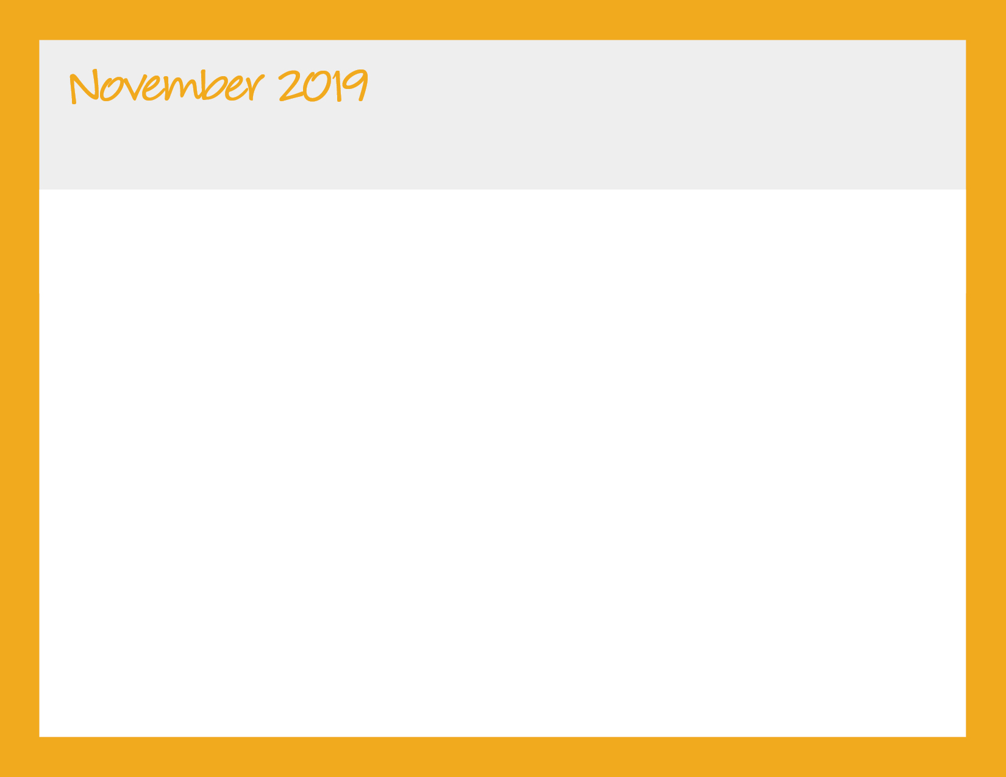

|  |  |  |  |  |
| --- | --- | --- | --- | --- |
| **Monday** | **Tuesday** | **Wednesday** | **Thursday** | **Friday** |
| * Water is served with each meal and snack * Whole milk is served to children under the age of 2 years * 1% milk is served to children 2 years and older | | | | 1 Waffles, Turkey Bacon, Fruit, Milk  Cheeseburgers, Corn, Fruit, Milk  V- Garden Burger  Veggie Straws, Apples |
| 4 Cheerios with Milk, Bananas  Grilled Chicken, Green Beans, Roll, Fruit, Milk  V- Tofu  Pita Bread & Hummus, Apples | 5 Raisin Toast, Apples, Milk  Grilled Cheese, Tomato Soup, Broccoli, Fruit, Milk  Soft Pretzel & Oranges | 6 Oatmeal, Strawberries, Milk  Soft Beef Tacos, Black Beans, Fruit, Milk  V- Cheese Quesadilla  Cereal Trail Mix & Berries | 7 English Muffin with Sun Butter, Fruit, Milk  Tilapia, Veggie Stir Fry, Pears, Milk  V- Tofu  Veggie Straws & Apples | 8 Applesauce, Graham Crackers, Milk  Turkey & Cheese Sandwich, Potato Salad, Fruit, Milk  V- Cheese Sandwich  Whole Wheat Crackers & Fruit Cocktail |
| 11 Bagels with Cream Cheese, Fruit  Swedish Meatballs, Noodles, Peas, Fruit, Milk  V-Tofu  Graham Crackers & Oranges | 12 Chex Cereal with Milk, Bananas  Black Bean Burrito , Spanish Rice, Corn, Fruit, Milk  Whole Wheat Crackers & Avocado | 13 Graham Crackers, Apples, Milk  Tuna Sandwich, Broccoli, Pears, Milk  V- Hummus Sandwich  String Cheese & Apples | 14 Yogurt, Fruit  Orange Chicken, Brown Rice, Mixed Veggies, Mandarin Oranges, Milk  V- Tofu  Soft Pretzel & Peaches | 15 Blueberry Muffin, Apples, Milk  Beef Stew, Cornbread, Fruit, Milk  V- Veggie Stew  Sun Butter & Jelly Sandwich , Fruit |
| 18 Rice Krispies with Milk, Fruit  Spaghetti & Meatballs, Garlic Bread, Peas, Fruit, Milk  V- Plain Spaghetti  Fruit Cocktail & Crackers | 19 Pancakes, Turkey Sausage, Fruit, Milk  Cod, Rice, Black Beans, Pears, Milk  V-Tofu  Pita Bread & Hummus | 20 Raisin Toast, Bananas, Milk  Turkey with Gravy, Dinner Roll, Sweet Potatoes, Fruit Milk  V- Tofu  Graham Crackers & Fruit | 21 Oatmeal, Apples, Milk  Grilled Chicken, Mashed Potatoes, Broccoli, Fruit, Milk  V- Tofu  Veggie Straws & Melons | 22 English Muffin with Sun Butter, Fruit, Milk  Cheese Pizza, Green Beans, Fruit, Milk  Cereal Trail Mix & Berries |
| 25 Blueberry Muffin, Bananas, Milk  Chicken Fajitas, Spanish Rice, Pinto Beans, Fruit, Milk  V- Veggie Fajitas  Soft Pretzel & Apples | 26 Yogurt, Fruit  Soft Beef Tacos, Black Beans, Fruit, Milk  V- Cheese Quesadilla  Sun Butter & Jelly Sandwich, Fruit | 27 Applesauce, Graham Crackers, Milk  Tuna Sandwich, Broccoli, Pears, Milk  V- Hummus Sandwich  String Cheese & Wheat Crackers | 28  **Center**  **Closed** | 29  **Center**  **Closed** |

Bright Horizons at Legacy

972-427-4905 | legacy@brighthorizons.com | brighthorizons.com/legacy