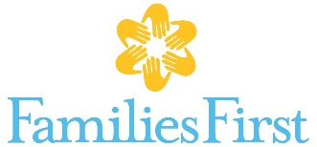 What we’re wishing for….
Father Engagement program
- Baby gates
- Adult bicycles
- Car seats and booster seats
- Gift cards for transportation: Uber, Lyft, gas, weekly or 30-day IndyGo bus pass
- Gift cards for kid-friendly restaurants, ice cream, etc.
- Passes to kid-friendly entertainment for supervised visitation: 2 adults plus at least 1 child to zoo, Conner Prairie, Children’s Museum, swim parks etc.

Domestic Violence & Family Counseling
- Snacks for adult program groups
Parent education, Child’s Haven, Parent Café
- Post-It Self-Stick Easel Pad (4)
- Disposable cups, plates, forks
- Re-usable bowls, cups, sippy cups
- DVDs – toddler to elementary age (Inside Out movie, healthy choices, bullying, etc.)
- Toys – toddler age
- Board games – ages 6-12
- Disposable baby diaper changing pads
- Lysol spray
- Dishwasher detergent
Domestic violence and sexual assault programs
- Legal services for clients – particularly family-law
- Snacks for children’s groups and one-on-one counseling
- Craft items for adults and children

Homebased family preservation
- Baby gates
- Source material – up-to-date, evidence-based worksheets, workbooks, games
- Gift cards for kid-friendly restaurants, ice cream, etc.
- Gift cards for transportation: Uber, Lyft, gas, weekly or 30-day IndyGo bus pass
- Zoo membership

