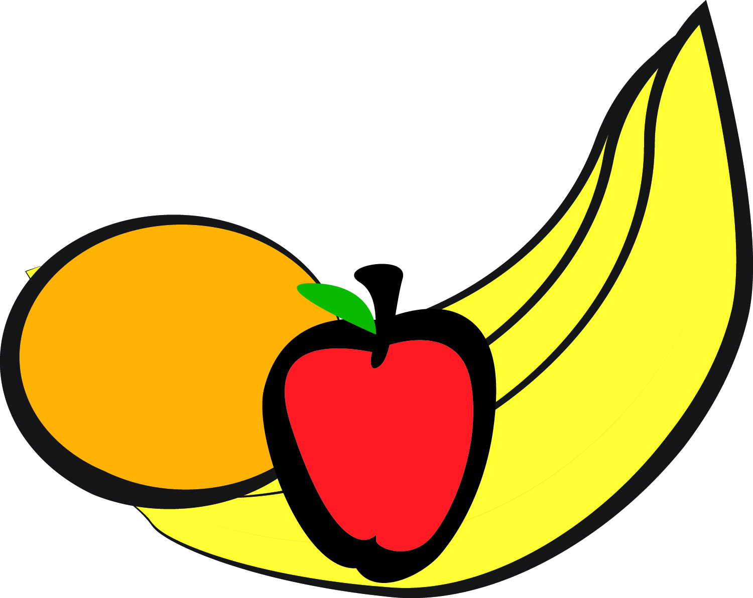
Rotating Bi-Weekly Snack Menu

Bright Horizons at Riverpark

 | Monday | Tuesday | Wednesday | Thursday | Friday
AM SNACK  PM SNACK |  |  |  |  | Bagels  Cream Cheese  Banana  Pita Chips , Tabouli, and Carrots
AM SNACK  PM SNACK | Graham Crackers  Banana  Cucumbers  Cheese Sticks | English Muffins  Sun Butter  Apples  Pita Chips , Tabouli, and Carrots | French Toast Sticks  Apples  Wheat Thins  Corn | Oatmeal  Berries  Rice Cakes  Sun Butter  Apples | Yogurt  Orange  Cucumbers  Pita Chips
AM SNACK  PM SNACK | Sausage  Orange  Apples  Cheese Sticks | Yogurt  Orange  Pita Bread  Carrots  Tabouli | Cereal  Apple/Oranges  Strawberries  Graham Crackers

