Happy Birthday!!

Lea G. – June 2nd

Sage M. – June 4th

Tobias K. – June 5th

Ms. Ashley R. – June 5th

Freya N. – June 10th

Ms. Candice – June 10th

Matisse H. – June 11th

Ms. Asia – June 11th

Ms. LaToya – June 11th

Maya S. – June 12th

Ms. Ann – June 15th

Gabriel G. – June 16th

Cameron D. – June 19th

Ruby S. – June 20th

Maxwell M. – June 21st

Mason P. – June 22nd

Oscar G. – June 26th

Leonard J. – June 28th

Martin H. – June 29th

Ms. Alyssa – June 30th

2018 | June Newsletter

Bright Horizons at   
Adams Street News

**From the Director**

Happy June Everyone!

As the season of graduations is upon us, we are excited (and sad) to celebrate our K-Prep friends accomplishments and wish the well on their new adventures. Please keep an eye out for invitations in the coming weeks!

We also want to celebrate all of the important men in our children’s lives. We invite all of them to join us for a small brunch on Friday, June 15th. Details will be sent out from your child’s teachers.

I would like to personally apologize for the all of the facility/maintenance issues that have occurred over the past couple weeks. Though they were all unforeseeable we could have anticipated them happening, we do understand the inconvenience they may have placed on your family. I assure you that we are working closely with our facilities manager to make sure that each issue is taken care of and minimize the chance of it happening again in the future.

As always, my door is always open with any questions or concerns.

Take care,

TJ McNamara Director

Important Dates

June 12th – Family Partnership Group Meeting

June 15th – Father’s Day Brunch

June 22nd – K-Prep Graduation

July 2nd – Summer Kick-Off Picnic

July 4th – CLOSED

****Bright Horizons at Adams Street****

345 Adams St. Brooklyn, NY 11201

(718)488-7770 | [adamsstreet@brighthorizons.com](mailto:adamsstreet@brighthorizons.com)

Monday – Friday 7:00 am – 6:30 pm

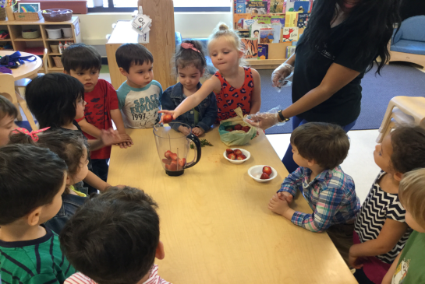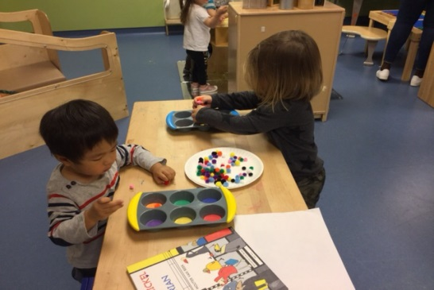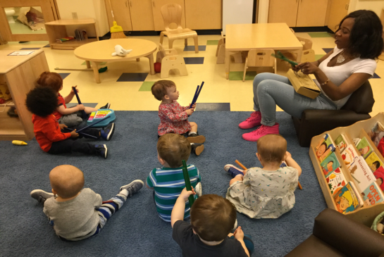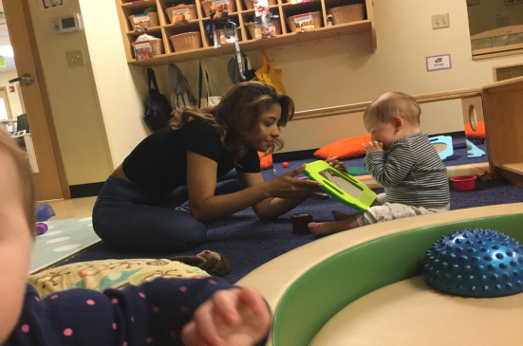

Toward a Better World

Through the curriculum Toward a Better World, teachers encourage a baby’s natural sense of curiosity by guiding their exploration of the world around them. Our Infants learn to recognize and identify themselves in a mirror and develop a sense of self as separate from others.

Art Smart

Art Smart ensures that children are introduced to the visual arts, music, dance/creative movement, and drama. We learn to move in response to music and rhythm, and experiment with instruments and sounds. We learn this by experiencing diverse music with simple beats and rhythms, while playing, shaking, touching, and strumming instruments.

Math Counts

Math Counts offers a framework for developing the skills and abilities of young mathematicians, ensuring that children recognize math in everyday life. Our Young Preschoolers learn to sort objects by one or more characteristics. We learn this by sorting items based off of different characteristics, such as color.

Well Aware

Well Aware provides preschoolers with varied opportunities and materials to develop concepts of wellness, such as the knowledge and skills to practice healthy lifelong habits. We learn to understand the concept of healthy food and identify nutritious foods.

Program HIGHLIGHTS

It’s never too early to start “growing readers”! Research has shown that children who have a close adult who reads to and with them -- especially in the very early years -- learn language and literacy skills, develop an appreciation of books, and experience stronger family relationships.

Reading with your child can be one of the most rewarding and memorable ways to spend time together. In addition to having lasting effects on cognitive, language, and literacy development, sharing books inspires your child’s curiosity and creativity. Cuddling up with a book is an intimate activity that builds strong, loving, lifelong bonds.

**A few tips for reading with your child:**

* Designate a regular time and place to curl up together with a book. Invite your child to select books but also introduce new stories.
* Before you begin a new book, talk about the title, the cover, the author, and the illustrator. Ask thought-provoking questions about the book. "What do you think this story is about?"
* Understand that young children love to hear the same stories over and over again. Repetition provides a level of comfort and enables children to become the experts on the storyline. Also, it allows them to get familiar with the words, and eventually “read” the book to you.
* Make reading interactive; ask questions such as, “What do you think happens next in the story?” Or "How would you handle this situation?” It’s interesting to hear your child’s impression of the story.
* Expand your child’s horizons. When your child develops a new interest, go to the library and find books on that subject.
* Have fun and be playful! When you read aloud, try to make your voice exciting and dramatic for the different parts of the story.

There is so much multicultural, informative, historical, traditional, silly, experiential, and even futuristic literature for young children these days. Refer to “Bright Horizons Growing Readers” to access family resources, books suggestions, at-home reading activities, and tips on reading aloud.

[**www.brighthorizons.com/childrenbooks**](http://www.brighthorizons.com/childrenbooks)

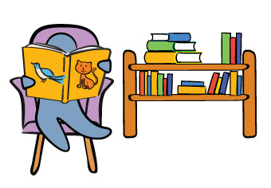



Homegrown Readers

Ready for school News

Learning at Home: Summer Activity

BRIGHT HORIZONS NEWS

Our Learning at Home ideas offer parents fun ways to extend their child's learning opportunities beyond the classroom to take advantage of teachable moments that naturally emerge from everyday life situations.

**Beach in a Bottle** – *Suitable for Kindergarten, Multi-Age, Preschool, School Age, Toddler, Twos*

**You will need:**

A trip to the beach, lake or creek, and supplies: plastic bottle, super glue, permanent marker, and a label

**Directions:**

Have your child fill the bottle with sand and water from the beach, along with their favorite sea shells or small pieces of driftwood. Seal the top using super glue (keep the glue out of your child’s reach and let the bottle dry before using it with them). Label with the date and location of your outing.

[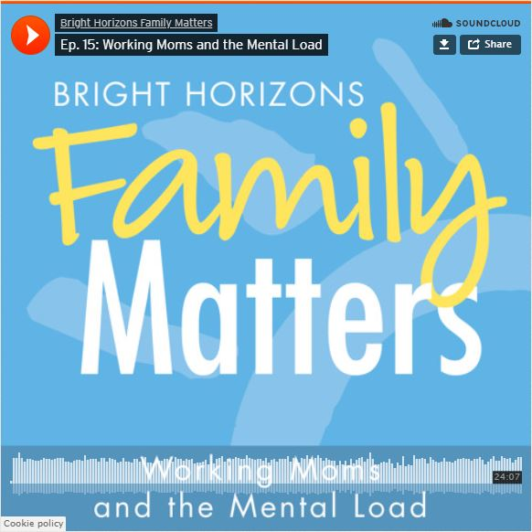](https://www.brighthorizons.com/family-resources/podcasts/working-moms-mental-load)

**New Parenting Podcast Episode!**

Peaceful Parenting on Busy Workdays

We’ve all been there… the get-out-the-door chaos, the after-work frenzy, those toddler-parent moments when things just seem to go kaboom! Is there a better way? Parenting expert and psychologist Jennifer Gillette says unequivocally… yes.

On this episode of the *Work-Life Equation*, Gillette has the tips, tricks, and strategies to tame the tantrums and put what she calls Peaceful Parenting back into your busy day.

[**Ep. 17: Peaceful Parenting on Busy Workdays**](https://soundcloud.com/user-48566546/ep-17-peaceful-parenting-on-busy-workdays)[www.brighthorizons.com/peacefulparenting](http://www.brighthorizons.com/peacefulparenting)



Check out all the places you can connect with us!

