<Organization Name> Fundraiser
Elite Sport Socks available to order!
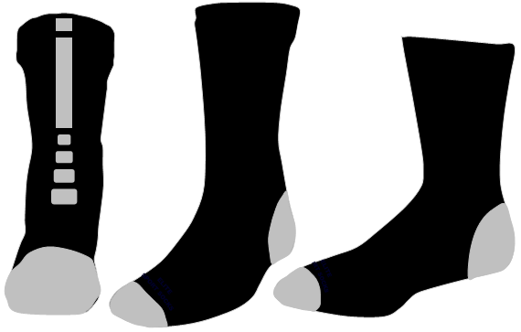
-----------------------------------------------------------------------------------------------------
ORDER FORMS DUE: <ENTER DATE HERE>
Student Name: Parent Name:
Phone: Email:
Grade: Teacher:

Please Put Quantity In Appropriate Size Box
 | X-Small | Small | Medium | Large | X-Large | Price / Pair | TOTAL
“Black” Design |  |  |  |  |  | $18.00

Sizing Guide | X-Small | Small | Medium | Large | X-Large
Men (USA Shoe Size) |  |  | 4 - 9 | 10 - 13 | 13 - 16
Women (USA Shoe Size) |  | 3 - 8 | 9 - 12
Child / Youth (USA Shoe Size) | 2C - 9C | 10C - 3Y | 4Y - 9Y

Please return all order forms by <DATE> to <NAME>.
Make checks payable to: <ENTER DETAILS HERE>

