November 2019
 | MONDAY | TUESDAY | WEDNESDAY | THURSDAY | FRIDAY
Nov 1 |  |  |  |  | 1  Deli Sandwich  Sweet Potato Waffle Fries  Mixed Fruit
Nov 4- Nov 8 | 4  Cheese Pizza  BBQ Baked Beans  Tropical Fruit Salad | 5  Toasted Cheese  Sweet Peas  Diced Peaches | 6  Hamburger Patty  Whole Grain Bun  Emojis  Applesauce | 7  Pasta with Beef Sauce  Garlic Knot  Corn  Fresh Mandarins | 8  Chicken & Waffles  Diced Carrots  Mixed Fruit
Nov 11-Nov 15 | 11  Toasted Cheese  Green beans  Tropical Fruit Salad | 12  Mini Twin Cheeseburgers  Cheesy Cauliflower  Diced Peaches | 13  Cheese Pizza  BBQ Baked Beans  Applesauce | 14  Cheesy Bean Dip  Wheat Crackers  Fresh Mandarins | 15  Chicken Patty  Whole Grain Bun  Sweet Potato Fries  Mixed Fruit
Nov 18- Nov 22 | 18  Cheese Quesadilla  Salsa  Tropical Fruit Salad | 19  Hamburger  Potato Emojis  Diced Peaches | 20  Chicken Spudster Bowl  BBQ Baked Beans  Applesauce | 21  Sliced Turkey, Mashed Potatoes & Gravy  Corn Bread Flats  Fresh Mandarins | 22  Chicken Nuggets  Seasoned Broccoli  Mixed Fruit
Nov 25- Nov | 25  Cheese Pizza  Broccoli & Cheese  Tropical Fruit Salad | 26  Salisbury Steak, Mashed Potatoes & Gravy  Dinner Roll  Diced Peaches | 27  WoWich  Spudsters  Applesauce | 28  Happy Thanksgiving- Small Wonders Closed  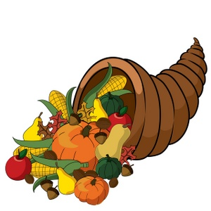 | 29
November 2019 Snack Menu
 | MONDAY | TUESDAY | WEDNESDAY | THURSDAY | FRIDAY
Menu items are subject to change without notification | Whole Grain Soft Pretzel & Milk | Whole Grain Mini Muffin Loaf & Applesauce | Yogurt & Fresh Fruit | Whole Grain Granola Bar & Milk | String Cheese & Honey Graham Crackers
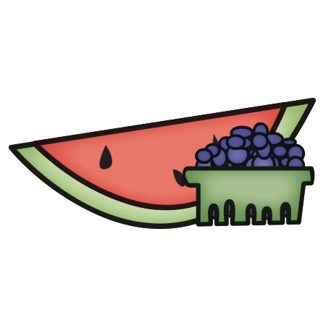
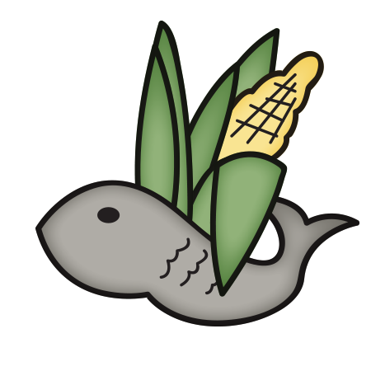
Small Wonders has additional options daily for snack such as:
- Yogurt
- Fresh Fruit
- Cheerios, Rice Chex, Corn Chex, Rice Krispies
- Nutrigrain Bars
- Sun Butter and Pita Bread

Child Nutrition
All weekly menus meet the following guidelines based on the USDA nutrition standards for 2015:
- Acceptable calorie range for the age group
- All grains served are whole grains
- <10% of calories from saturated fat
- National sodium guidelines
- Five sub-groups of vegetables offered
- Choices of fruit and vegetables offered daily

