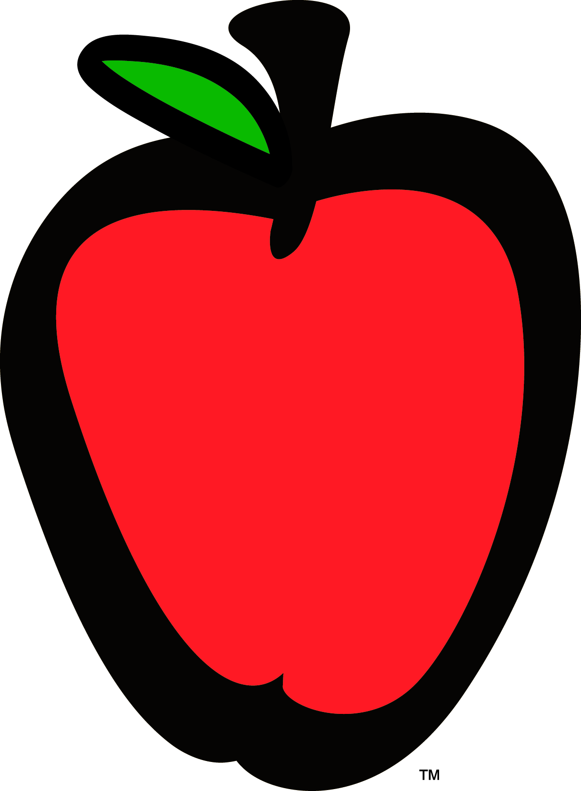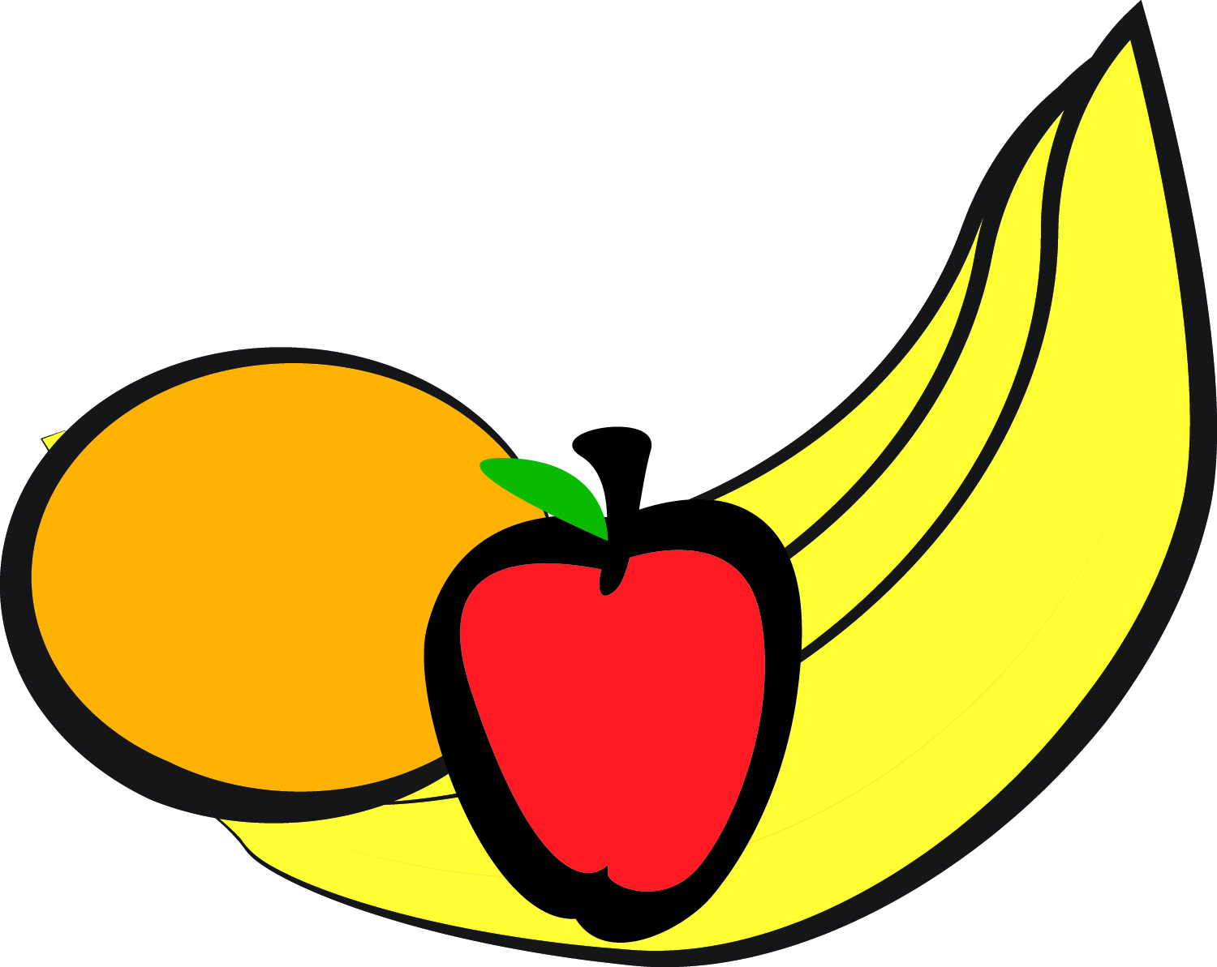

Little Apron Academy

December 2018

|  |  |  |  |  |
| --- | --- | --- | --- | --- |
| **MONDAY** | **TUESDAY** | **WEDNESDAY** | **THURSDAY** | **FRIDAY** |
| **3**  **AM Snack: Cheese Toast**  **Turkey Sausage**  **Scrambled Eggs**  **Baked Apples**  **Lunch: Vegetarian Lasagna**  **Tropical Fruit**  **PM Snack: Vanilla Wafers**  **Sliced Oranges** | **4**  **AM Snack: Vanilla Yogurt**  **Apricots**  **Lunch: Turkey Burgers**  **Sweet Potato Fries**  **Peaches**  **PM Snack: Wheat Crackers**  **String Cheese** | **5**  **AM Snack: Cheese Grits**  **Turkey Bacon**  **Pears**  **Lunch: Zesty Orange Chicken**  **Basmati Rice**  **Steamed Capri Vegetables**  **Pineapples**  **PM Snack: Graham Crackers w/ Mixed Berries** | **6**  **AM Snack: Cream of Wheat**  **Fruit Medley**  **Lunch: Corn Taco Shell w/ Ground Turkey**  **Chuck Wagon Corn**  **Baked Apples**  **PM Snack: Mixed Berry Muffins** | **7**  **AM Snack: Chex Cereal**  **Pineapple**  **Lunch: Tomato Soup**  **Grilled Cheese**  **Pears**  **PM Snack:**  **Cheese Crackers**  **Peaches** |
| **10**  **AM Snack: Apple Muffins**  **Fresh Melon**  **Lunch: Chicken Alfredo**  **Normandy Vegetables**  **Apples**  **PM Snack: Turkey w/ Cheese**  **Wheat Thins** | **11**  **AM Snack: Cheese Grits**  **Turkey Sausage**  **Peaches**  **Lunch: Baked Spaghetti**  **Squash**  **Tropical Fruit**  **PM Snack: Spinach Dip and Pita Bread** | **12**  **AM Snack: Bagels& Cream Cheese**  **Pears**  **Lunch: Chicken Noodle Soup w/veggies**  **Pineapples**  **PM Snack: Apples & String Cheese** | **13**  **AM Snack: Oatmeal**  **Bananas**  **Lunch: Turkey Lasagna**  **Green Beans**  **Fresh Melon**  **PM Snack: Baked Peach Crisp** | **14**  **AM Snack: Hash Browns Turkey sausage Mixed Fruit**  **Lunch: Veggie Quesadillas**  **Sweet Corn**  **Pears**  **PM Snack: Zucchini Bread Muffins** |
| **17**  **AM Snack: Cheerios & Bananas**  **Lunch: Chicken Teriyaki w/ Stir Fry Vegetables**  **Basmati Rice**  **Mandarin Oranges**  **PM Snack: Guacamole w/ Wheat Crackers** | **18**  **AM Snack: Blueberry Muffins**  **Pineapple**  **Lunch: Cheese Ravioli w/ Meat Sauce**  **Mixed Vegetables**  **Mixed Fruit**  **PM Snack: Graham Crackers w/ Peaches** | **19**  **AM Snack: Oatmeal**  **Fresh Melon**  **Lunch: Baked Chicken**  **Normandy Blend**  **Steamed Spinach**  **Corn Muffin**  **Pears**  **PM Snack:**  **Sun Butter & Raisin Toast** | **20**  **AM Snack: Bagels Cream Cheese Tropical Fruit**  **Lunch: BBQ Chicken Pizza**  **Sweet Corn**  **Fresh Melon**  **PM Snack: Yogurt Parfait w/Mixed Fruit Puree** | **21**  **AM Snack: Cream of Wheat**  **Bananas**  **Lunch: Chicken Minestrone Soup w/ Breadsticks**  **PM Snack: Vanilla Wafers w/ Apricots** |
| **24**  **AM Snack: Oatmeal**  **Pears**  **Lunch: Lemon Pepper Chicken w/Broccoli Cheese Casserole**  **Melon**  **PM Snack: Hummus & Veggie Sticks** | **25**  **C**  **L**  **O**  **S**  **E**  **D** | **26**  **AM Snack: Chex Cereal**  **Fruit Medley**  **Lunch: White Bean & Veggie Chicken Chili**  **Corn Muffin**  **Apples**  **PM Snack: Yogurt & Berries** | **27**  **AM Snack: Cream of Wheat**  **Mango**  **Lunch: Turkey Meatloaf**  **Collard Greens**  **Jasmine Rice**  **Pears**  **PM Snack: Banana Bread** | 28  **AM Snack: Scrambled Eggs**  **Turkey Bacon**  **Fresh Melon**  **Lunch: Macaroni & Cheese**  **Green Beans**  **Corn Bread**  **Peaches**  **PM Snack: Graham Crackers w/ Oranges** |
|  |  |  |  |  |

**LAA Serves whole milk to children under two years of age and 1% milk to children over two years of age.**

**Milk is served at AM snack and lunch. Water is served at PM snack**